# MMO Kit Remaster: Documentation

For UE 5.1

***Note on December 30:*** *This doc is a work-in-progress.*

***Note on May 27, 2023:*** *This doc is now* ***deprecated****, refer to the* [*5.2 version*](https://docs.google.com/document/d/18Z-rjsbtRIHul4ykZ7n0VEfmmKVyBBm2WQ1d5YntfMI/)*.*

## Support

For support, please visit the [official Discord server](https://discord.gg/9X7fy4m85w) or this email: codespartan.supp (at gmail.com)

The kit is young and many new features will be added over time. We’ll hold a voting for features that are most needed by the community, once the list is compiled. Don’t miss it.

## Getting Started

Assuming you’re working in UE5 from Epic Launcher, install the [MMO Kit Code Plugin](https://www.unrealengine.com/marketplace/en-US/product/mmo-kit-code).

### Opening the project

Outside of Play, the world will look empty:

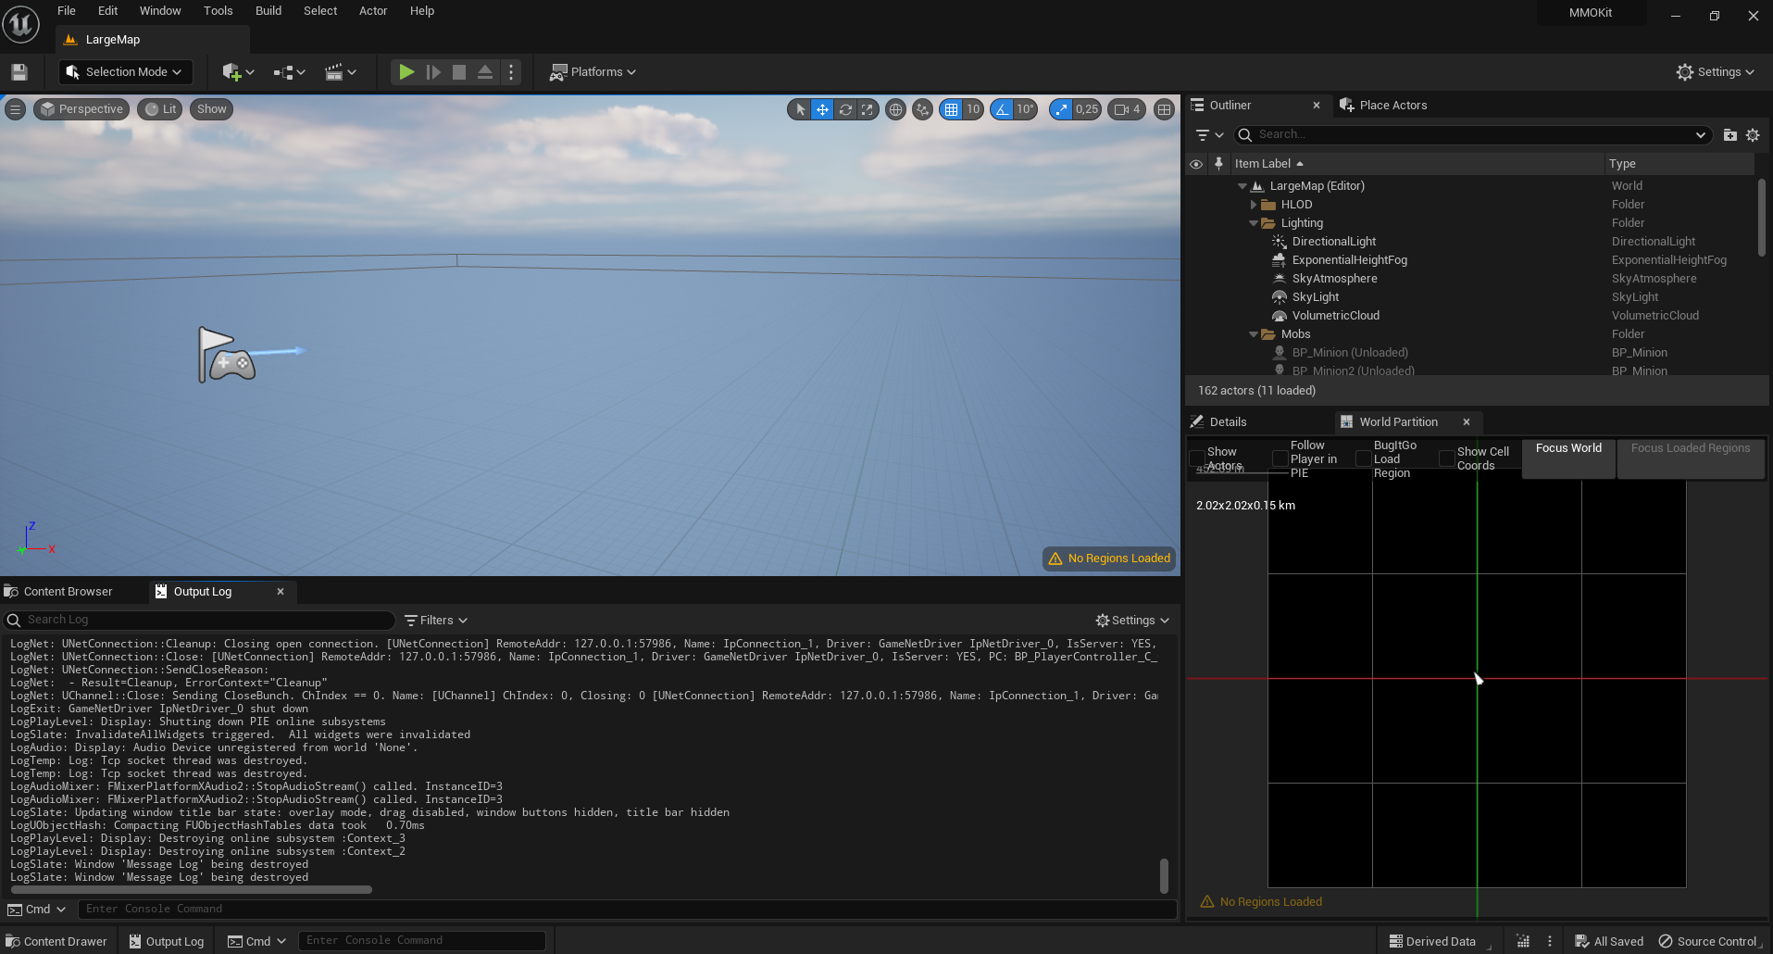

Open the World Partition Editor:

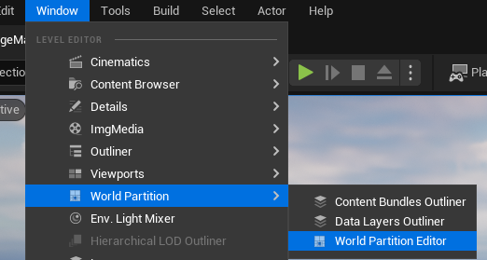

Draw a large rectangle in the World Partition, right click on it & hit “**Load Region from Selection**”. Landscape and mobs will appear.

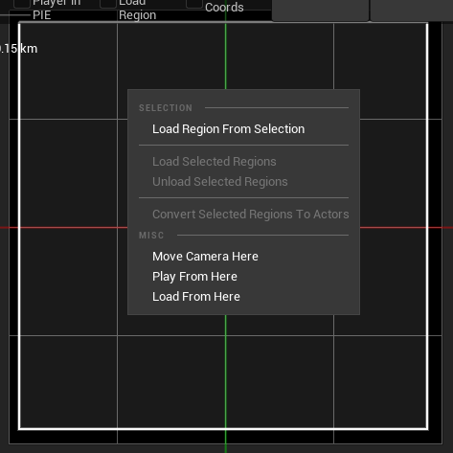

Click on the three dots in the panel above. Select **Play As Client** in the **Net Mode**.

Select the Number of Players, e.g. 1 or 2.

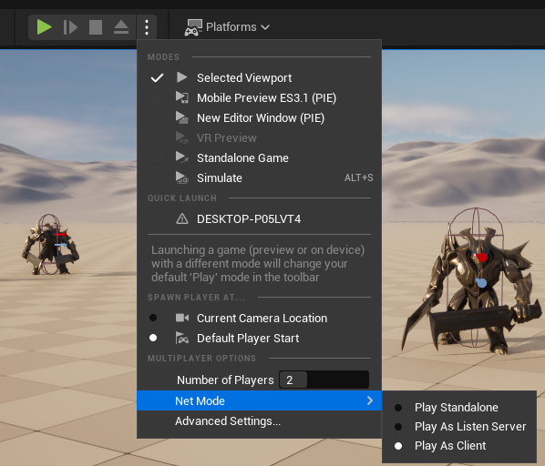

Before you can hit “Play”, you need to launch Persistence Server.

It is located in **/AdditionalFiles/PersistenceServer_Sources.zip**. Unzip it, open PersistenceServer.sln in Visual Studio, **select Debug-Sqlite** configuration and launch it:

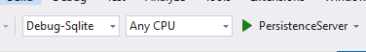

*Note: you’ll need* [*Visual Studio 2022 Community*](https://visualstudio.microsoft.com/vs/community/)*, as well as* [*.Net 6.0*](https://aka.ms/dotnet-download) *and* [*.Net Framework 4.6.2 (Developper Pack)*](https://dotnet.microsoft.com/en-us/download/dotnet-framework/thank-you/net462-developer-pack-offline-installer)

You should see the following:

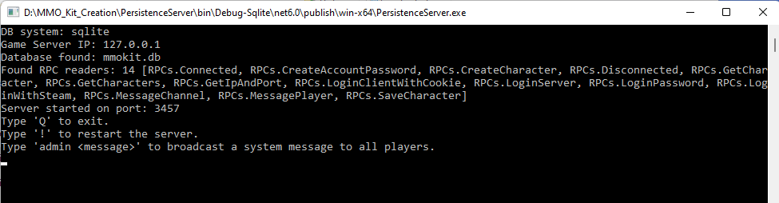

You would’ve been able to play at this point, but you don’t have any characters in the database.

Open the **MMO_Maps/StartMap** and hit Play. Create an account and a couple of characters.

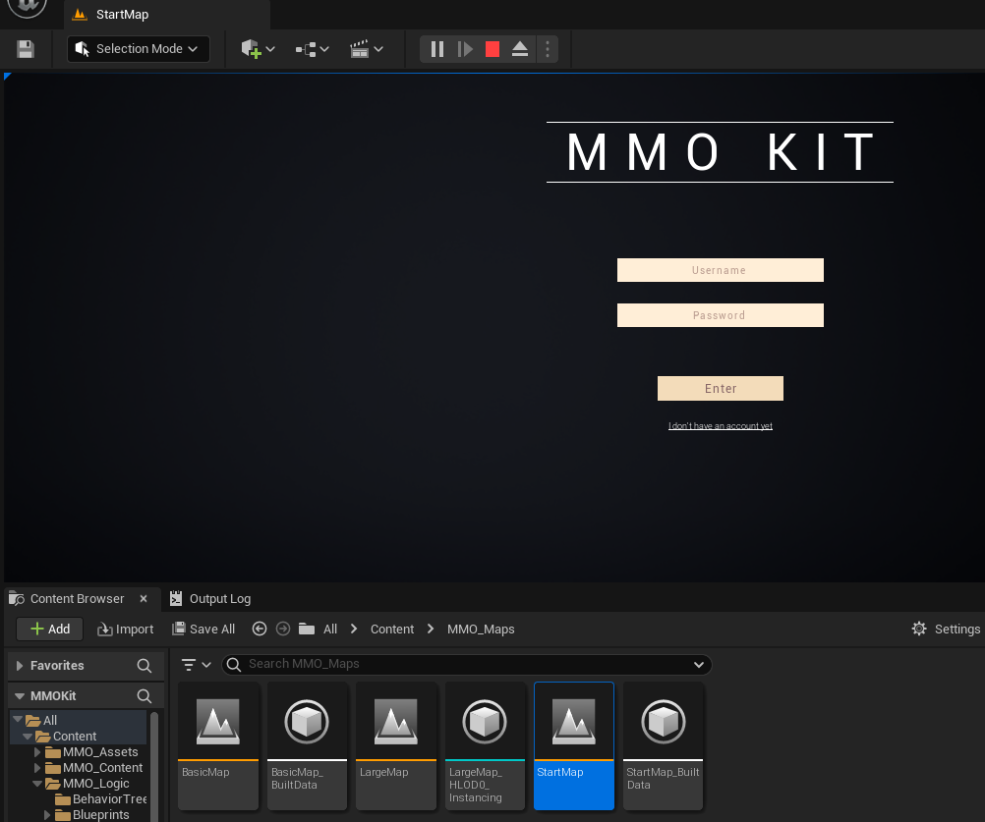

When you play in the **LargeMap**, the first window gets the first character, the second window gets the second character, etc. So if you need to test the game with 3 characters, be sure to have 3 characters in the DB. Don’t hit the “ENTER” button to enter world, because the Editor can’t switch maps. Instead, hit Stop simulation.

Now you can finally go back to **MMO_Maps/LargeMap** and hit “Play”, resulting in your character spawning from your newly created DB:

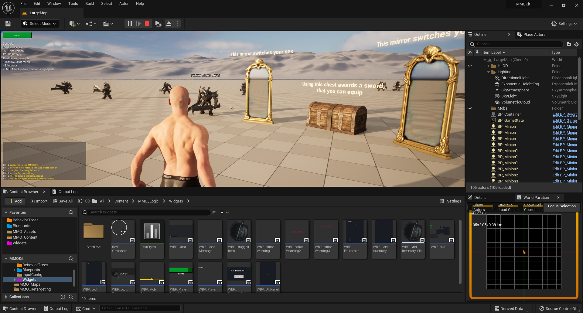

### Tip

Go to Edit - Editor Preferences - type “late join” and set **Allow late joining** to true. This will give you the following button:

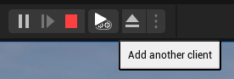

It’s useful for debugging mechanics related to states, e.g. you can late-join a character to try and witness an opening door, or see if a mob is truly dead when you haven’t witnessed him die, but have come into view of him later.

### BasicMap

BasicMap is set up to easily create hands animations for first person. We’ll talk about it later.

# Architecture

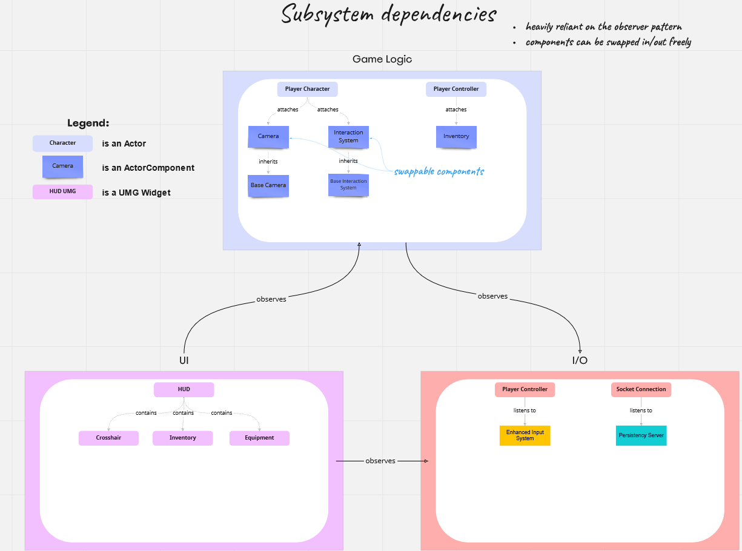

The architecture in MMO Kit was concieved with **modularity** in mind.

An example of it is 3 interchangeable camera components (first person, third person, wow-style), which inherit from BaseCameraComponent. The goal of it is to allow you to create your own camera component if you so desire.

Another trait is the **observer pattern**. Whenever possible, classes are self-sufficient and simply watch other classes for event dispatchers. For instance, when a player’s inventory updates, the Inventory component won’t try to call a method on any widget. It’s the widgets who are going to “watch” for changes, and the Inventory component will only dispatch an event, without knowing who is subscribed to it.

I’ll talk about each system more in detail later. But to give an example, here’s how the inventory system works:

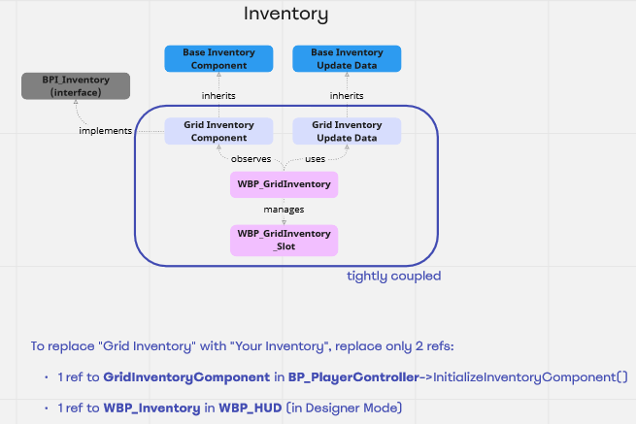

To make your own inventory system, you’d have to

* create your own classes to replace the 4 classes in the center
* replace only 2 references outside of the inventory system.

Replacing it with your own system would not disrupt the rest of the project.

I’ll try to record a video of the procedure in the future, where I create a different sort of inventory.

## Files structure

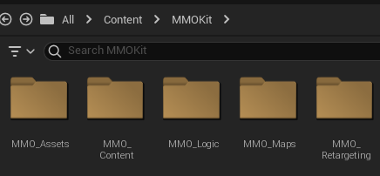

**Assets**: contains meshes, animations, icons, materials, control rigs, physics assets.

**Content**: contains game items (e.g. sword), abilities, appearances and mobs.

**Logic**: contains blueprints, widgets, behavior trees and input configs.

**Maps**: contains 3 maps.

**Retargeting**: contains IK retargeters and IK rigs to allow easy animation retargeting.

## Basic Blueprints

It bears reminding the role of some of the base blueprint classes in the context of replication. But before that, make sure you know the basics of UE5 networking - try watching [some of these videos](https://www.youtube.com/results?search_query=ue4+networking), they’re short and look very insightful.

### PlayerController

One PlayerController exists on each client. It’s replicated between the server and the associated client, but it’s not replicated to other clients, resulting in the server having PlayerControllers for every player, but clients having only the PlayerController for their local player.

In the kit, there’s only 1 blueprint of this class: **BP_PlayerController**

BP_PlayerController:

* Sets up the input config and listens to player input
* Creates the main HUD widget
* Participates in login
* Attaches 4 replicated components, including Inventory and Equipment

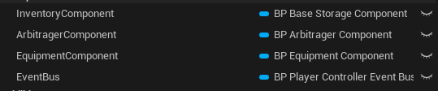

* Implements the following Interfaces:

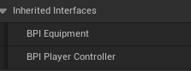

### PlayerCharacter

Exists on server & client, is replicated to all players within Net Cull Distance Squared.

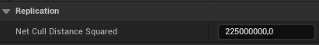

*This means 150 meters.*

In the kit, there’s 3 blueprints of this class: **BP_BaseCharacter**, which is a parent of **BP_PlayerCharacter** and **BP_MobCharacter**.

**BP_BaseCharacter** implements the following interfaces:

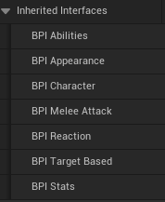

Characters are heavily reliant on the Appearance component for their Mesh and Animations.

**BP_MobCharacter** implements additional interfaces:

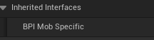

**BP_PlayerCharacter** implements additional interfaces:

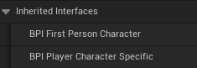

**BP_PlayerCharacter** and **BP_MobCharacter** attach a replicated StatsComponent and a non-replicated Event Bus.

**BP_MobCharacter** additionally attaches a non-replicated AiComponent (only Server-side).

We’ll see examples of usage of these Interfaces and Components when talking about various systems.

### GameInstance

A separate Game Instance exists on the server and on each client, and these instances **do not communicate** with each other.

Game Instance exists outside of the game session and is the only game structure that exists across level loads.

Game instance initializes before BeginPlay of all other Actors.

In the kit, this is **BP_GameInstance**.

### GameMode

GameMode exists only on the server.

In the kit, this is **BP_GameMode**.

### GameState

GameState exists on server and clients (only 1 instance for all), so the server can use replicated variables on the GameState to keep all clients up-to-date on data about the game.

In the kit, this is **BP_GameState**.

### PlayerState

PlayerState exists on Client and Server.

One instance per player.

Each instance is replicated to ALL OTHER players irregardless of NetCullDistance, so a MultiCast will be executed by everyone on the server. This is why I don’t use this class for almost anything.

### AIController

Exists only on the server. An instance per mob.

## Event Bus Pattern

I’m using this pattern to avoid Circular Dependencies in Blueprints.

Circular dependency is when Blueprints reference (and therefore depend on) each other in any way, e.g.:

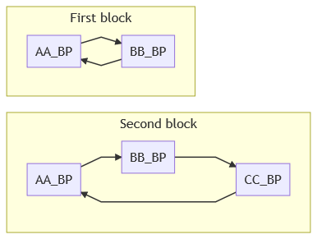

When blueprints A and B depend on each other, which one does the compiler compile first? This problem is solved in Blueprints in theory, but in practice it’s not so simple.

I’ve been working with UE4/5 for years and this problem often pops up after a few years of development, when projects grow huge. It can manifest in different ways: project won’t open (crash on startup), a particular blueprint doesn’t compile, build crashes, etc. For the MMO Kit, I’ve tried keeping the number of circular dependencies to a minimum (planning on eradicating them in the next updates) and had to rely on [Blueprint Interfaces](https://docs.unrealengine.com/5.1/en-US/blueprint-interface-in-unreal-engine/) and on the Event Bus Pattern.

Blueprints typically reference other blueprints with “cast” nodes:

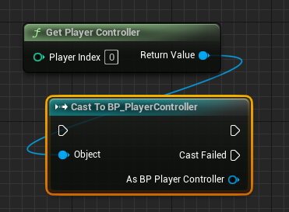

To avoid using a “cast” node, typically you’d create a Blueprint interface and make BP_PlayerController implement that interface.

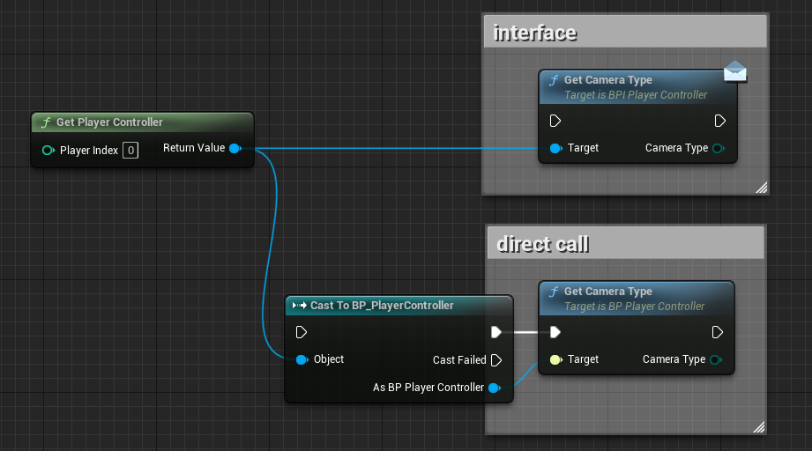

With an Interface, the Circular Dependency is resolved, because no cast is necessary:

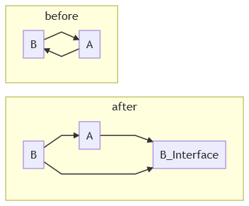

**However, using an Interface doesn’t allow us to call event dispatchers and this is where the Event Bus comes in.**

Event Buses are Actor Components.

To give an example, BP_PlayerController adds a BP_PlayerControllerEventBus on Construction script on the Server:

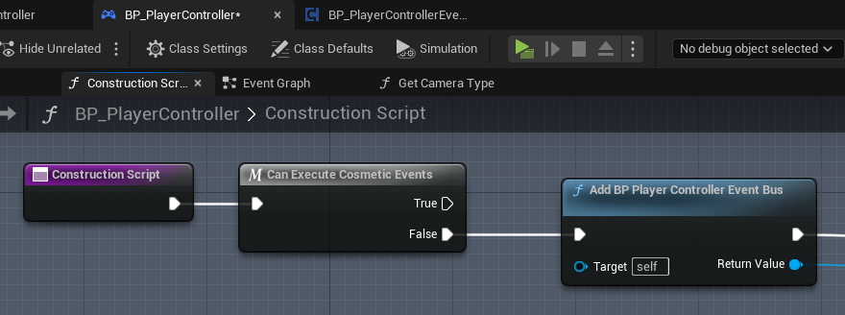

This event bus is replicated to owner clients.

OnRep, the clients bind EventBus’ events to its own functions:

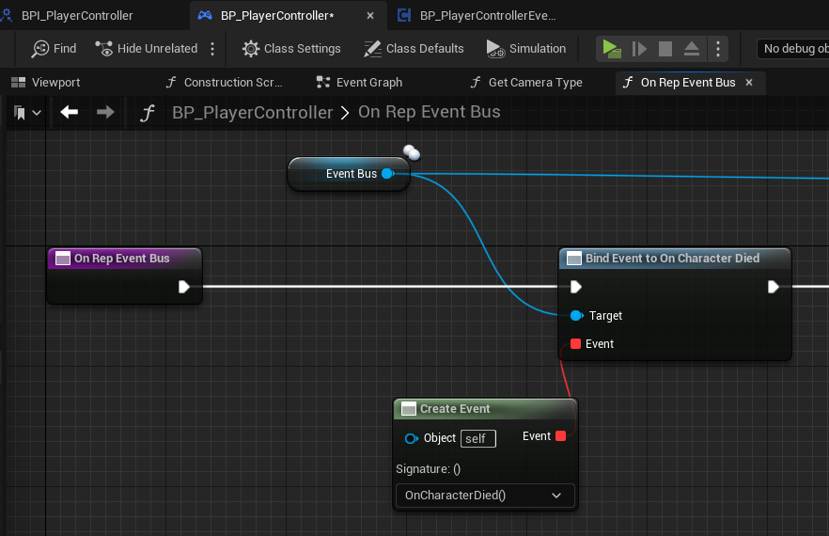

BP_PlayerController also returns its EventBus through an interface (BPI_Player_Controller). Hence, when PlayerCharacter wants to evoke an event on BP_PlayerController, it can do so through an event bus:

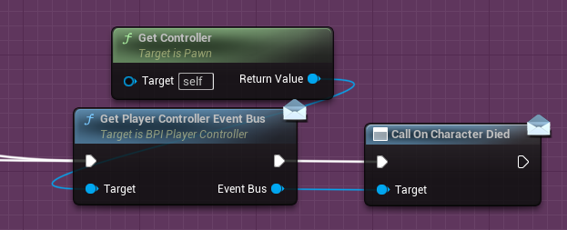

You don’t have to use this pattern yourself, but you need to understand how it works in order to understand the blueprint code in the MMO Kit.

# How-Tos

## Items

### Basic Items & Properties

There are two kinds of items at the moment: **BasicItems** (i.e. Junk items, because they don’t “do” anything, but they will serve as a basis for other item types) and **Equipment**, residing in MMO_Content/BasicItems and MMO_Content/Equipment.

To create a new Basic Item, Right Click in the Content Browser and select Miscellaneous -> Data Asset, then pick **BasicItemAsset** in the search box:

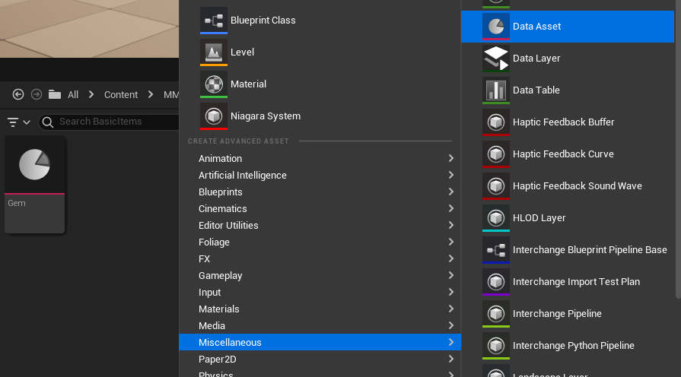

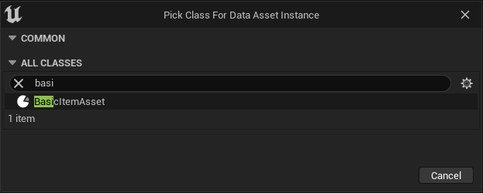

For equipment, pick **EquipmentAsset**:

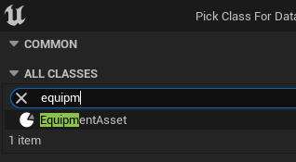

Each item exists as a separate file:

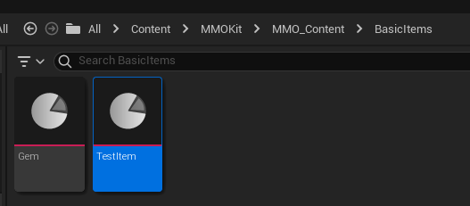

Note: if you place items outside of their directories, they will not be loaded by the AssetManager, unless you specify a new directory in the settings:

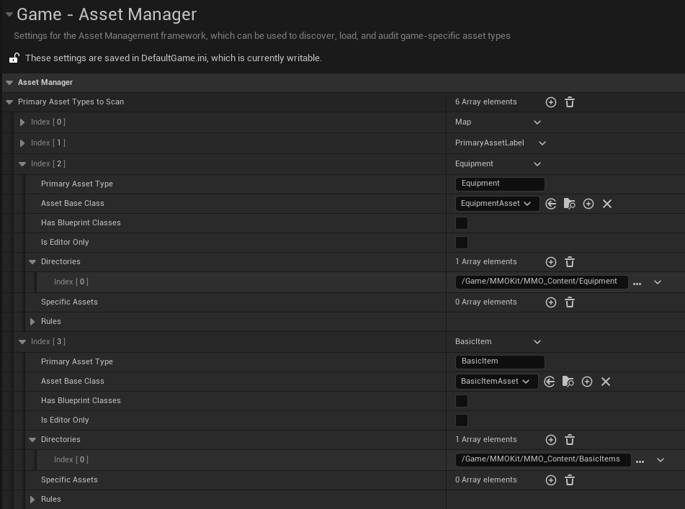

The resulting item will only have the following fields, because it’s a “Basic” item with no purpose.

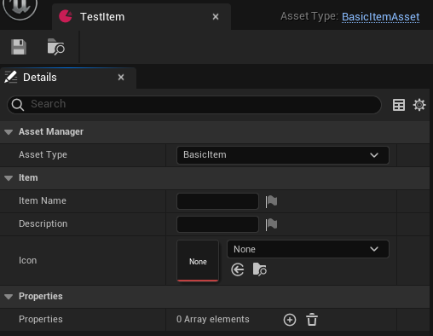

However, you can attach any properties. For example, let’s create a “Sellable” property.

Go to MMO_Logic/Blueprints/DataAssetTypes/ItemProperties/ and create a Blueprint Class that derives from ItemProperty

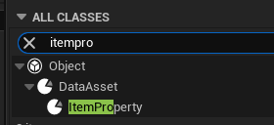

Add a variable “Price” to it:

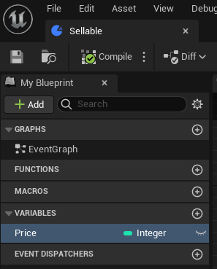

Open the “Gem” at MMO_Content/BasicItems and add a Sellable property to it. Now you can give it a price:

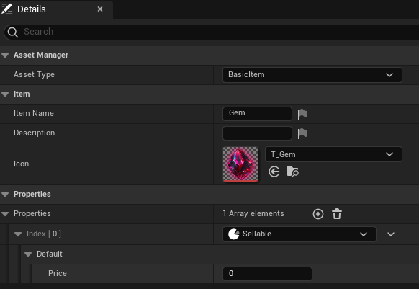

And if you want to make ALL BasicItems sellable, open DataAssetTypes/BasicItemAsset and give it a “Sellable” property. Then you can open your TestItem and it’ll have a sellable property, too.

**Alternatively**, you can open BasicItemAsset and give it a VARIABLE (instead of a property), e.g.:

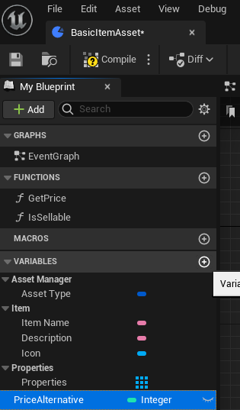

The result would be the new “Price Alternative” field:

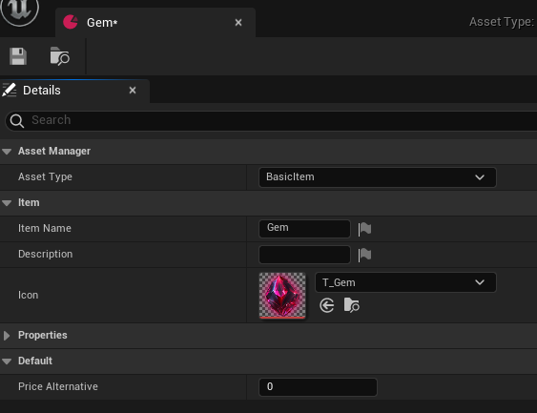

Continuing with the “property” example, since “Equipment” inherits from “BasicItem”, at this point your sword in MMO_Content/Equipment/Sword_01 will also have a *Sellable* property. If you want to quickly retrieve the price property in Blueprint code, open BasicItemAsset and give it a following function:

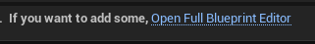

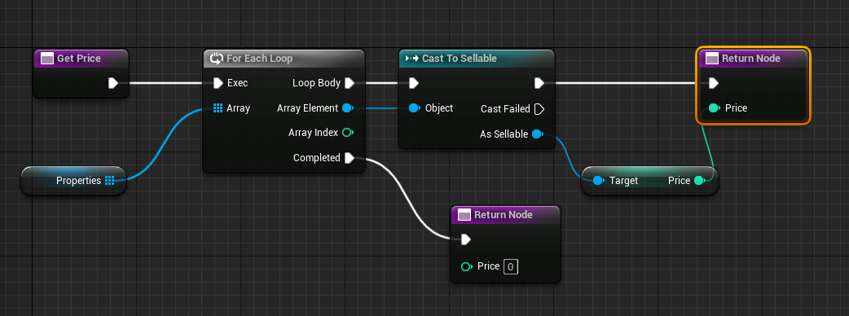

Whenever you have an item in Blueprints, you can now retrieve its price property like so:

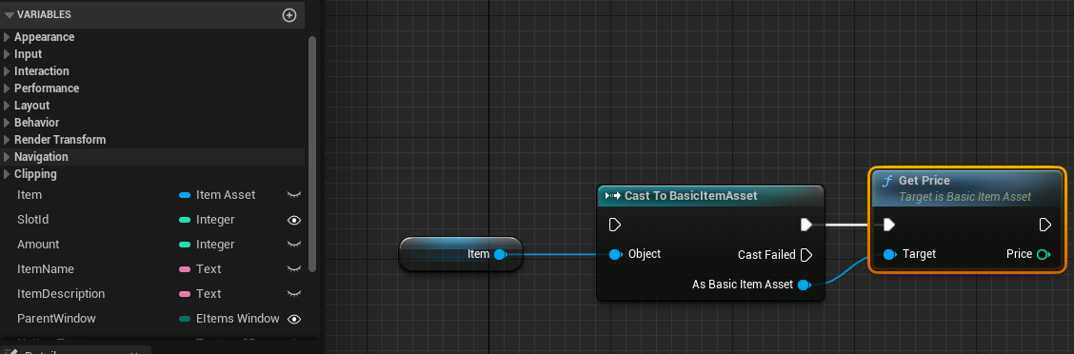

And if you want to check whether an item has a sellable property, the function would be similar to GetPrice, with minor changes:

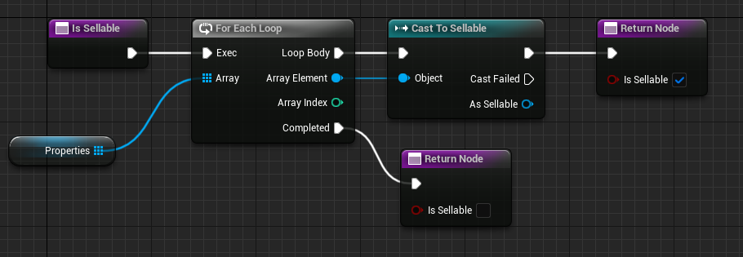

For basic things like integers, I recommend simply adding a variable, instead of a property.

Properties are more powerful, e.g. we can use them to add “Usable” logic, which I’ll add in the next updates. If you want to try doing it yourself, remember that properties can have functions..! So instead of retrieving a value from a property, you can call a method on it.

### New Item Types

To create new Item Types, go to DataAssetTypes and create a Blueprint class inheriting from “BasicItemAsset” and let’s call it a “QuestItemAsset”.

Create a directory “QuestItems” under MMO_Content.

Go to ProjectSettings -> AssetManager and add an element to the “Primary Asset Types to Scan”.

Call it “QuestItem”, assign “QuestItemAsset” to class and provide the correct directory.

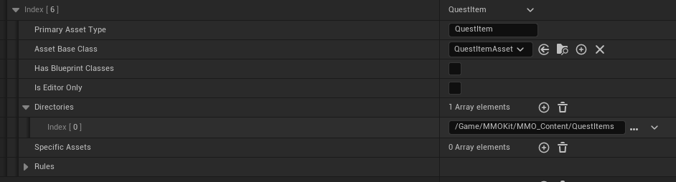

The name “QuestItem” that you give here is very important. Open “QuestItemAsset”, find “AssetType” variables and set its type correctly:

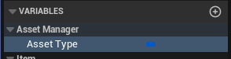

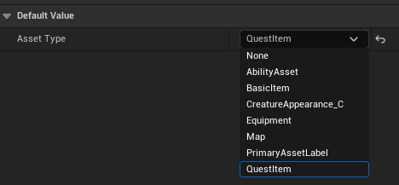

Now we’re going to tell GameMode to load all QuestItems on server start-up into memory. Open BP_GameMode, find the variable “PrimaryAssetsToLoad” and add your newly created asset type:

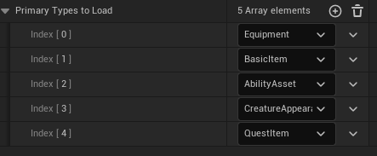

### Equipment

Equipment is an example of a “custom type” that I created as an example for you. It has additional fields:

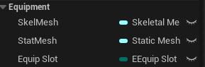

Static mesh will be used by default when trying to display an equipped item on your character. If none is found, the code will try getting a Skeletal Mesh. Some equipment items in MMOs have animations of their own, like swords with tentacles, but most of the time you should use static meshes.

To create an Equipment item, the procedure is the same. Right click -> Miscellaneous -> Data Asset -> pick “EquipmentAsset”.

The example sword has a “WeaponStat” property, which effectively turns this piece of equipment into a weapon.

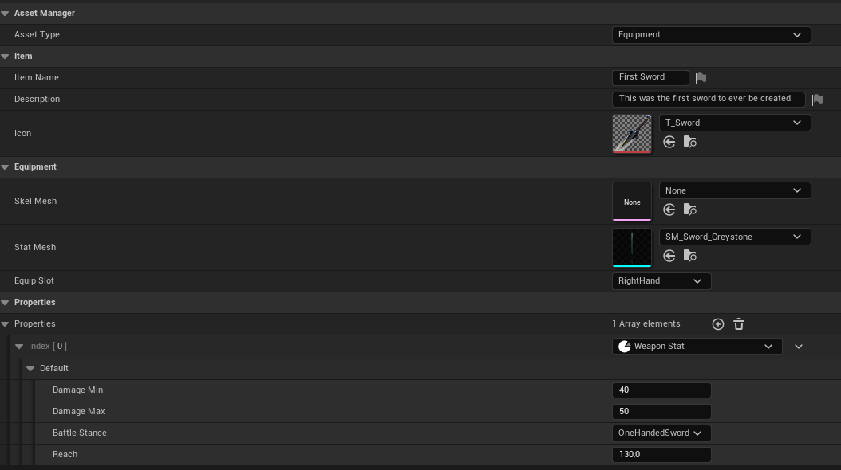

If you want your weapon stats to have different variables, simply modify the WeaponStat blueprint.

## Abilities

Abilities reside in MMO_Content/Abilities/ and consist of 2 files.

The first one is data, the second one is logic.

The logic file can be re-used for multiple abilities.

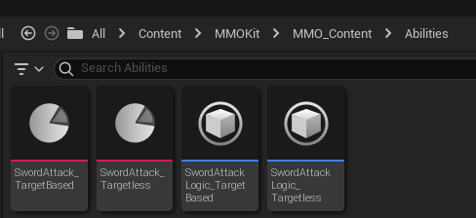

To create an ability, right click in the content browser, select Misc -> Data Asset -> Ability Asset

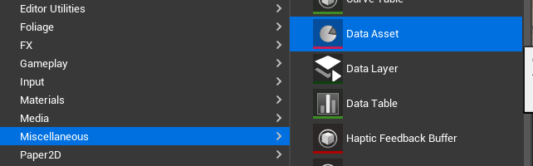

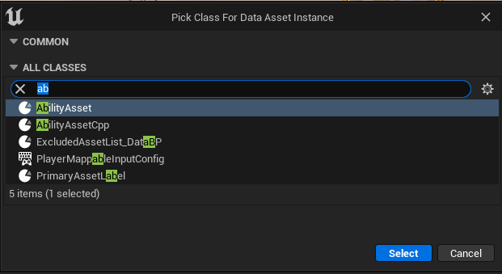

Then create a Blueprint class inheriting from AbilityLogic.

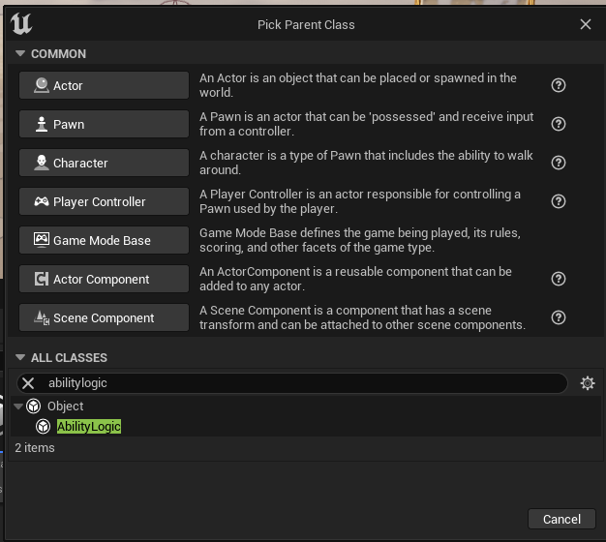

For our example, I’ll make an ability that heals its target (I’ll discuss both target-based and targetless variants). Open the newly created ability logic blueprint and give it an integer variable “HealAmount”.

Assign this logic to our newly created ability and set the amount:

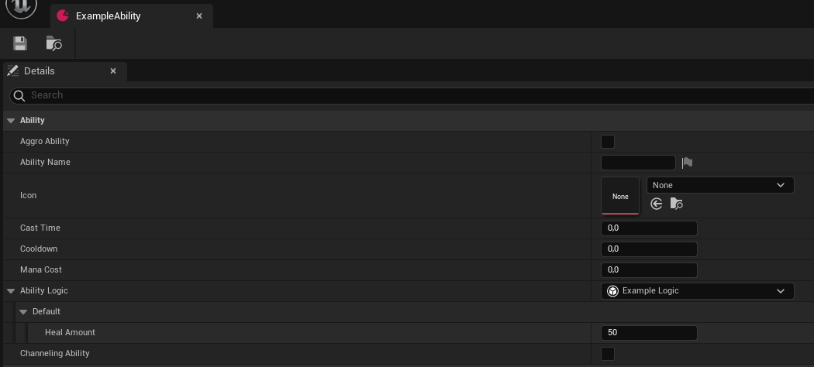

Open the Example Logic blueprint. It has 5 functions that you can override:

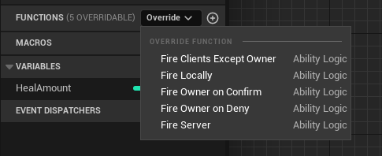

The first one that clients call is FireLocally.

For target based abilities, we should make sure that we have a target:

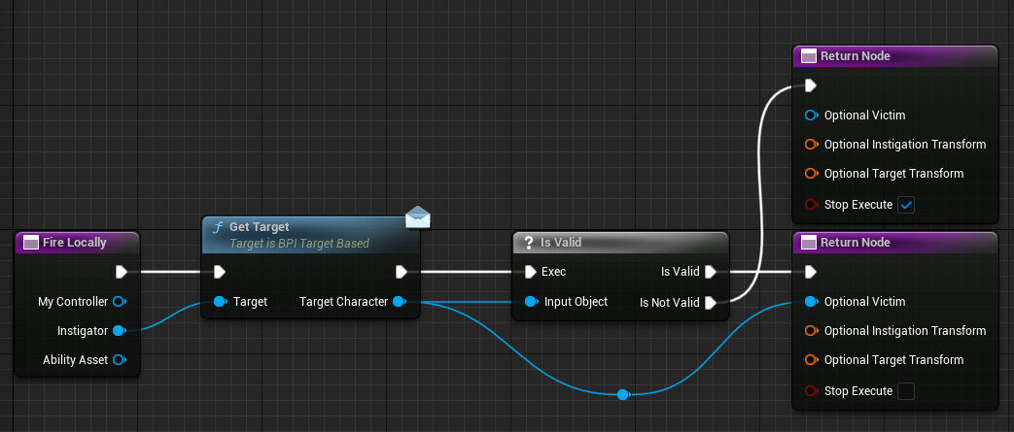

*By returning “stop execute”, we make sure the ability is cancelled if we have no target.*

For targetless, we need to provide the origin of our ability, because we’re going to do a linetrace from it:

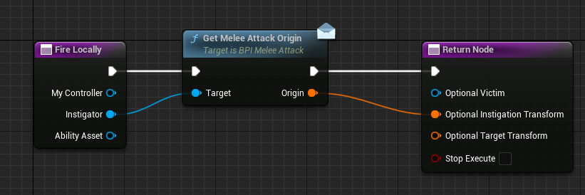

I’m skipping anything related to visuals, such as playing an animation, a particle or a sound. Check out the example logic blueprints I provided for the melee attack, they play animations and show a good place to play sounds.

Next, override FireServer:

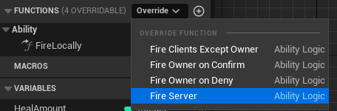

It’s on the Server that we’re going to perform the heal, because all gameplay is server-authoritative.

For a target-based heal ability, the logic is straightforward:

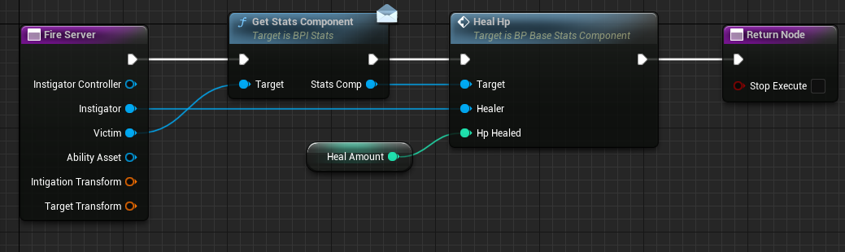

Again, I’m skipping particles or sounds.

*Note that an Ability Asset is a UObject, so it has no “world” and there’s only one instance of this class in the entire game. Hence, you can’t spawn a sound from it or do a MultiCast. To play a sound, create a method on BP_BaseCharacter and call it from the FireServer function, for example.*

For a targetless heal ability, we need to shoot a line-trace, but UObjects can’t do that. Open BPI_PlayerCharacterSpecific and add a LineTrace method with two parameters:

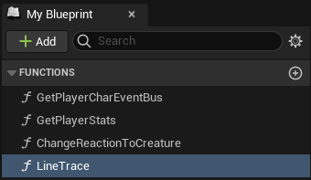

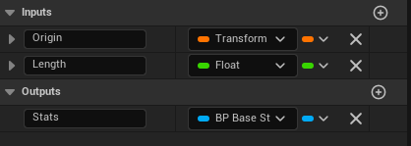

Open BP_PlayerCharacter and find this newly created method under Interfaces:

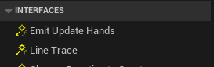

Double click it and give it some code:

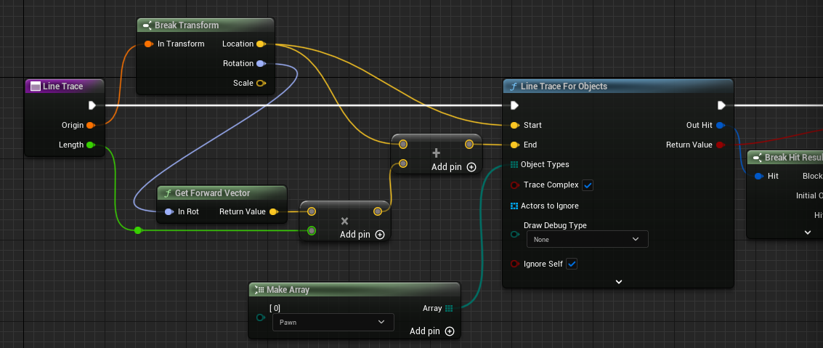

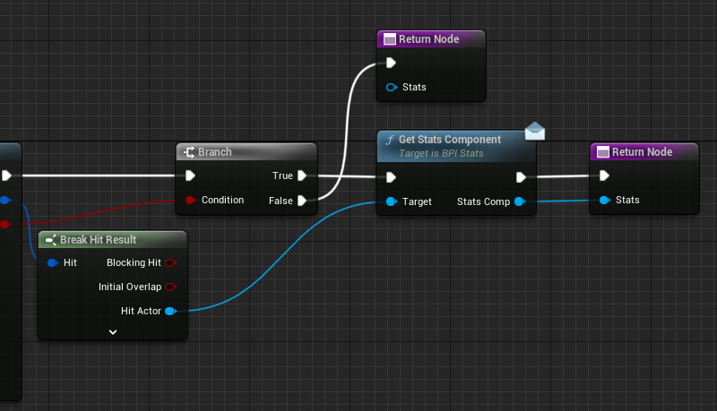

Back to our targetless ability:

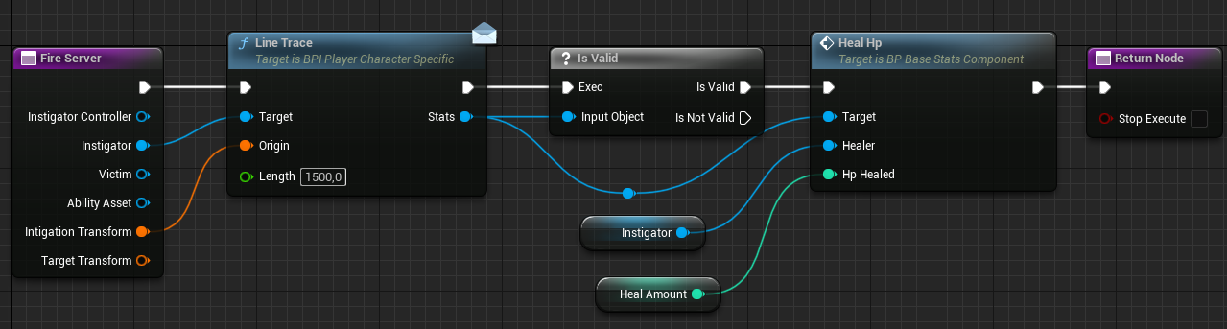

If FireServer returns “true” in the “stop execution” pin, then “Activate Ability **Deny** Owning Client” will fire on the instigator’s client, which we haven’t overridden in our example. It may be used to cancel an animation or a particle that you have already started playing.

If FireServer returns “false” in the “stop execution” pin, which would mean that the ability successfully fired, then “Activate Ability **Confirm** Owning Client” would fire on the instigator’s client. And “Activate Ability Clients Except Owner” would fire on all other clients.

As you may have noticed, abilities also have a “Cooldown” and “Mana cost”.

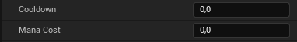

If the ability satisfies the requirements on the client, but doesn’t satisfy them on the server, then “Activate Ability **Deny** Owning Client” will fire on the instigator’s client.

To see in more detail how the system works, see **BP_AbilitySystemComponent**. It’s a very small blueprint with self-explanatory code, that you can adjust for your own needs. The entry-point is in this function:

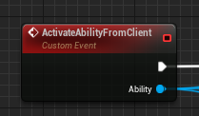

As I make more example abilities, I will undoubtedly make some changes to this blueprint.

Currently, as there are no ability trees and no hotbars, to give yourself an ability, use this method on BP_PlayerCharacter:

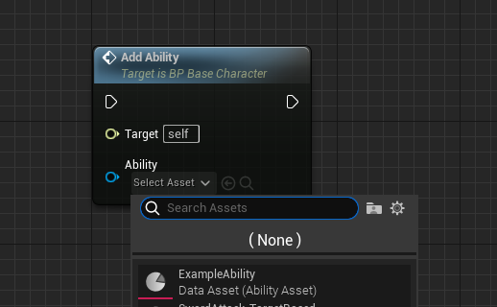

Only add or remove abilities on the server!

A primitive example of how to give yourself an ability, create a custom event:

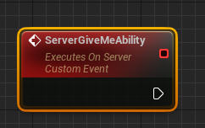

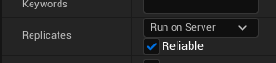

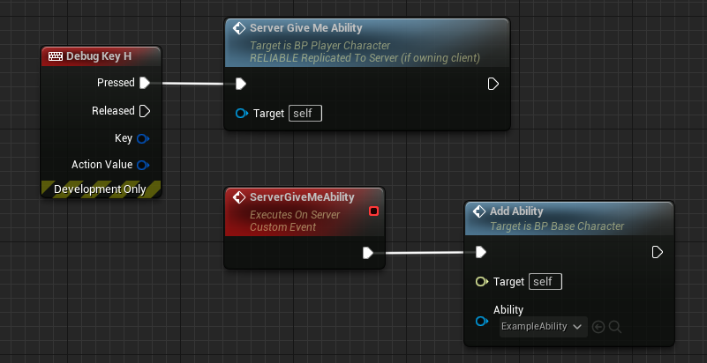

To activate from client, as a very rough example:

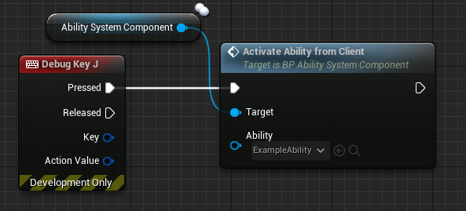

## Player Stats

### Creating and using the new stat

**BP_BaseStatsComponent** is a parent of BP_PlayerStatsComponent and BP_MobStatsComponent.

If you want to add a stat that is shared by players and mobs, you add it to **BP_BaseStatsComponent**.

Simply add a variable and set it to replicate. You can set replication condition to “Owner Only” if it’s a stat that you shouldn’t receive from other mobs and players, but only for your character. The reason the owning player should receive it is to be able to display it in a menu.

In this example, we’ll add ArmorClass:

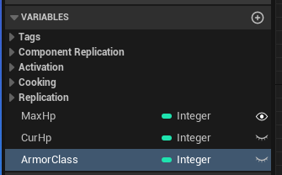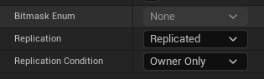

Now the stat exists. Players should receive this particular stat from equipment, while mobs should inherently get it from FStatsMob (more on that in Mobs -> Adding More Stats).

Open MMO_Login/Blueprints/DataAssetTypes/ItemProperties/ArmorStat. It just so happens that ArmorStat already has the ArmorClass variable, otherwise you’d add it here.

Once you add a WeaponStat property to any piece of equipment, you’ll be able to give it ArmorClass. I did it to the sword, since it’s our only equipment object in the project as of this writing.

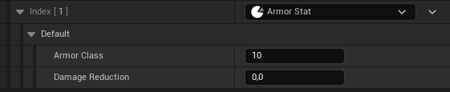

To make the equipment grant you this new stat, open BP_EquipmentComponent. There is a function “OnEquipmentChanged” that is fired on Server whenever equipment is updated. It’s a good place to add the stats from equipment to player. To this end, create a function called ApplyEquipmentStatsToPlayer and call it here:

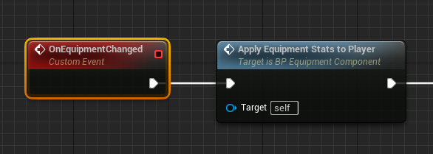

The logic of the function can be as follows.

1. Create a local variable in the function  
   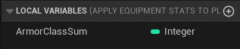
2. For each equipment, cast it to BP_EquipmentAsset:

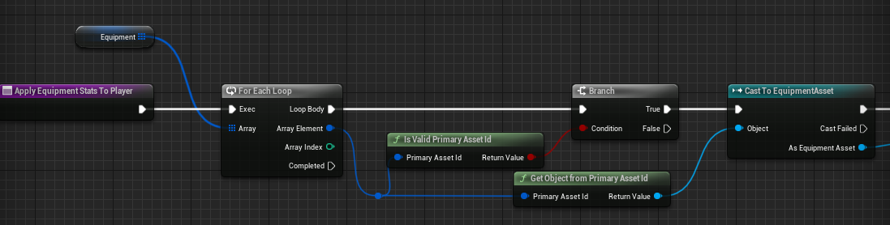

1. For each asset, get its Properties, find the ones that are “ArmorStat” and sum up their ArmorClass:  
   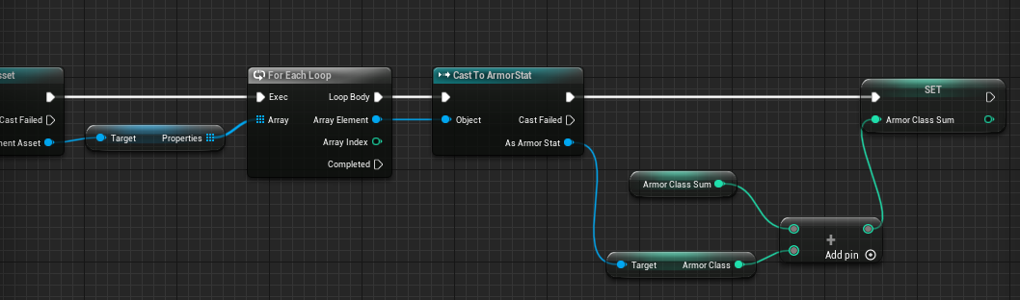
2. Set player armor class from the sum:  
   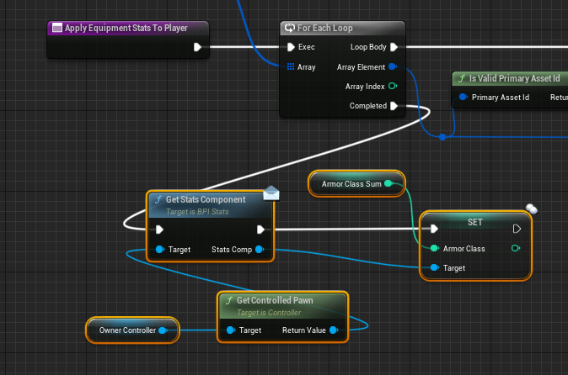

Adding stats to mobs is a bit different and is described in the Mobs section.

All that remains is to use the Armor Class in your game’s logic.

There are only two damaging abilities in the project right now, it’s SwordAttack_TargetBased and SwordAttack_Targetless. Depending on your preference, open the associated SwordAttackLogic and find the function “FireServer”:

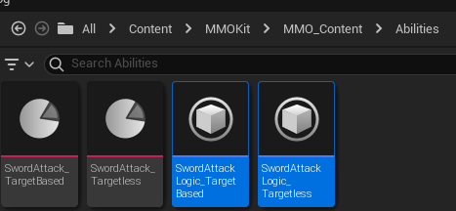

The following code is responsible for dealing damage:

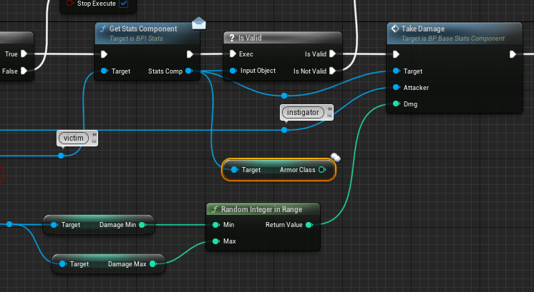

You could use AC right here in this method, or you could add it to the TakeDamage function.

### Saving stats to DB

Stats that are received from equipment shouldn’t be saved to DB, but rather recalculated every time a player is retrieved from DB and gets his equipment.

But let’s say you created a stat that needs to be saved and retrieved. Player stats are serialized in BP_PlayerStatsComponent -> GetSerializedStats:

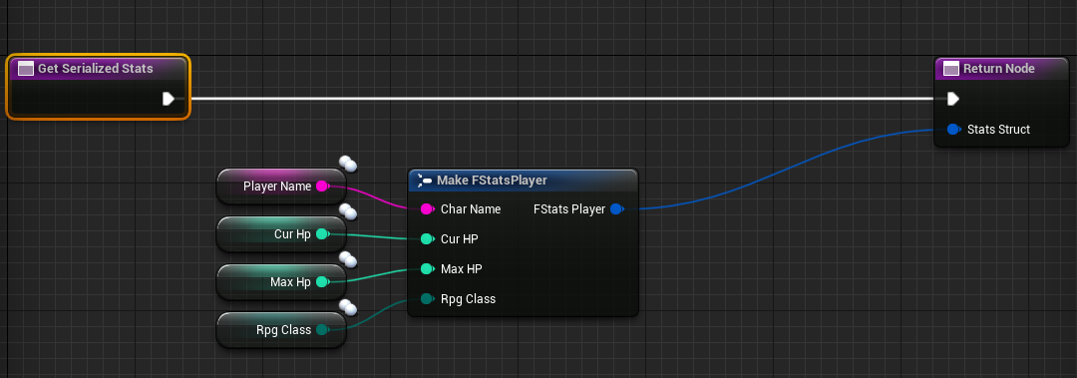

Add a new field to FStatsPlayer and a pin will appear here, too.

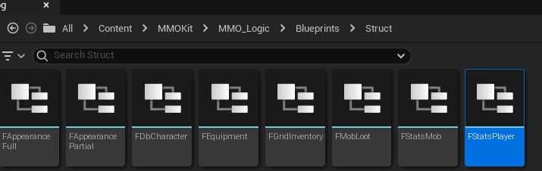

When the character relogs and his stats are retrieved from DB, they need to be assigned in BP_PlayerStatsComponent -> Initialize:

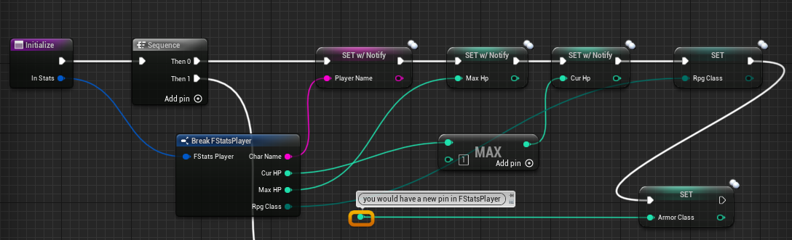

This is where you’d set the value from the received struct.

## Mobs

### Appearance

To create a mob, you first need to create its appearance in /MMO_Content/CreateAppearances/

Right click -> Miscellaneous -> Data Asset -> CreatureAppearance.

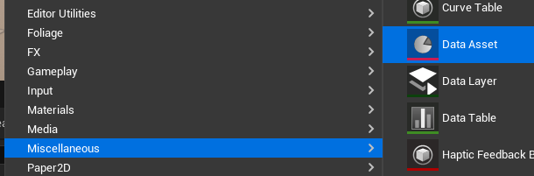

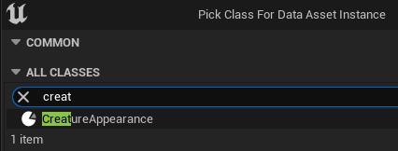

If you look at the already existence appearance called DarkMinion, you will see that it needs:

* A skeletal mesh (female skeletal mesh is optional)
* Anim Blueprint (female anim blueprint is optional)
* Death montage
* Attack montage(s) (dark minion has 4)

If you check the “player appearance” bool, this means that the appearance supports adding equipment. This is true for “human” and “mannequin” appearances, but is false for the dark minion, because the minion already comes with armor and weapon.

“Attach eyes” means the eyes will be placed into appropriate sockets. False for DarkMinion and Mannequin, but true for Humanoid.

### Mob

Create a Blueprint inheriting from BP_MobCharacter anywhere in /MMO_Content/Mobs/

Type “MobInitial” in the search box and you will see all the variables you can tweak for your mob:

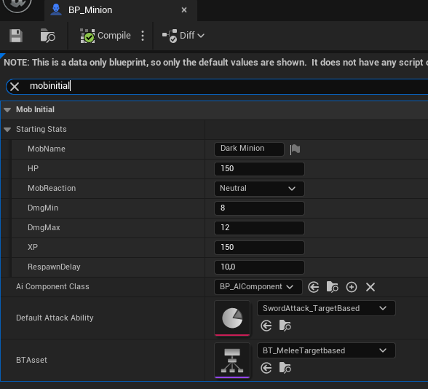

Some of the stats don’t show under “mobinitial”, but under “mob initial”, which is a bug to be fixed in the next update. These stats are:

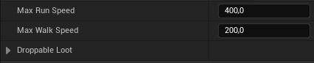

*Mobs walk out of combat, but run when in combat.*

*Loot drop chance must be set between 0 and 1.*

All these stats are also editable on a per-actor basis in the map.

Open full blueprint editor and select the Appearance Component

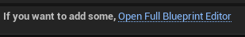

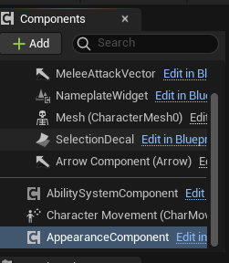

Set the mob’s Appearance that you just created, optionally setting the mob’s gear if your mob is humanoid:

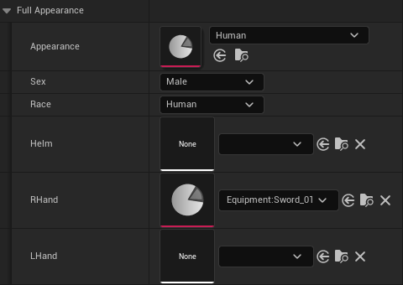

If you drag this new mob into the world, it will look empty:

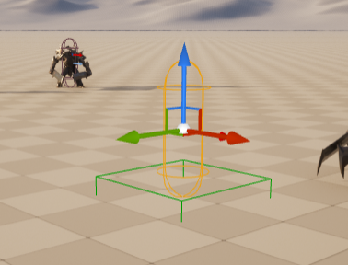

This is fine, because the Appearance is set on BeginPlay. But if you want to see what kind of mobs you have in your map, you can set the mob’s mesh manually, though what you set will be overridden by the Appearance.

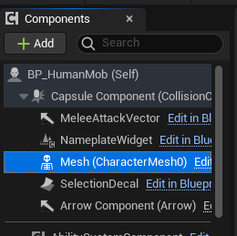

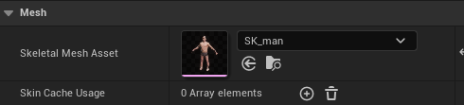

Now it’ll look like a man:

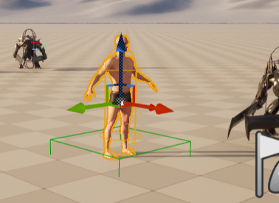

Be sure to set this mesh at least once, so you can adjust its vertical position, as well as capsule’s half height.

*In the current version, there’s a minor bug with the default mesh position & rotation. Set Position:Z to -88 and Rotation:Z to -90.*

*TODO: Capsule’s half height and radius should also be set in Appearance.*

### Mob Stats

Open MMO_Logic/Blueprints/Structs/FStatsMob and add a variable, e.g. “mana”:

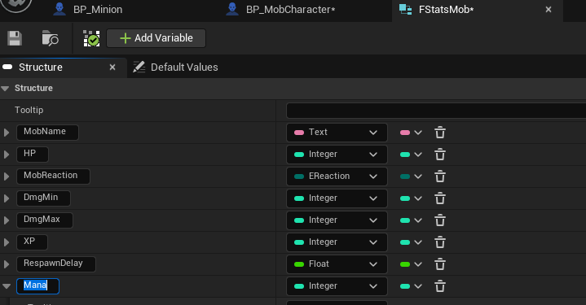

If you’re adding a mob-specific stat, then open Blueprints/Stats/MobStatsComponent. If it’s shared with players, then open Blueprints/Stats/BP_BaseStatsComponent and add the same variable “mana” there. Mark it as “replicated” and set replication condition, if you want clients to access this variable, e.g. to display it in mob’s nameplate.

In BP_MobCharacter, find the comment box that says “BeginPlay: set up stats & ai component”. Set the mob’s mana on its StatsComponent from the StartingStats:

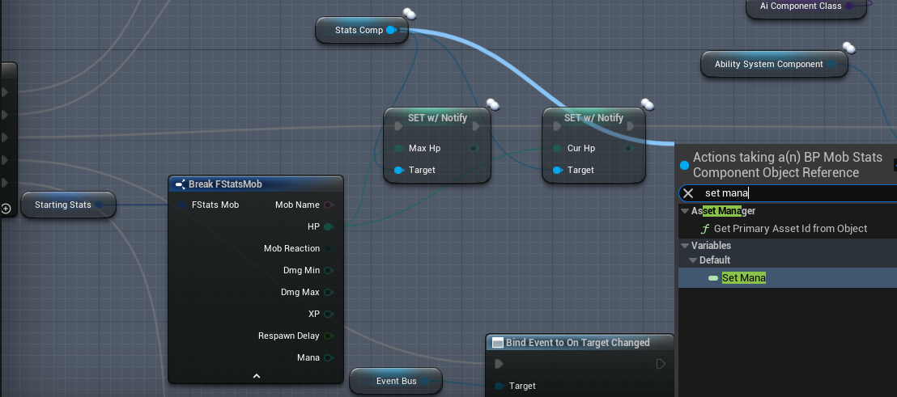

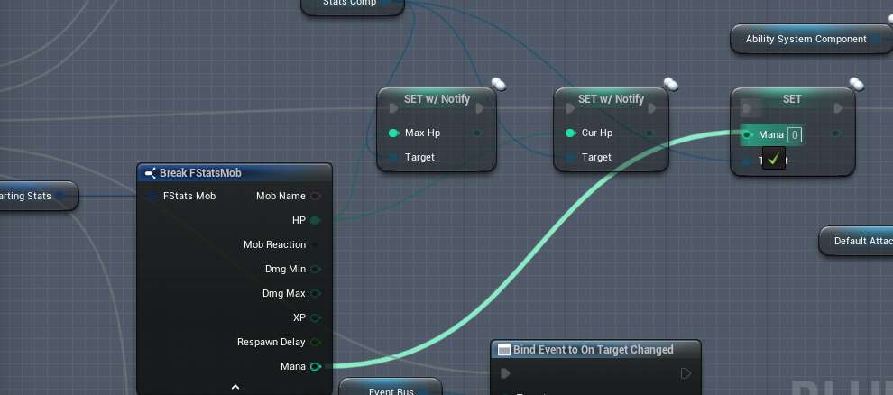

Now your mobs have a “mana” stat. Depending on what you want to do with your new mob stats, they can be used in BP_MobCharacter, BP_MobStatsComponent, BP_AIComponent or BP_AbilitySystemComponent.

For example, when a mob dies (BP_MobCharacter), it awards experience based on its “XP” Starting Stat. Since we assigned “mana” to the Stat Component on BeginPlay, it’s retrieved differently:

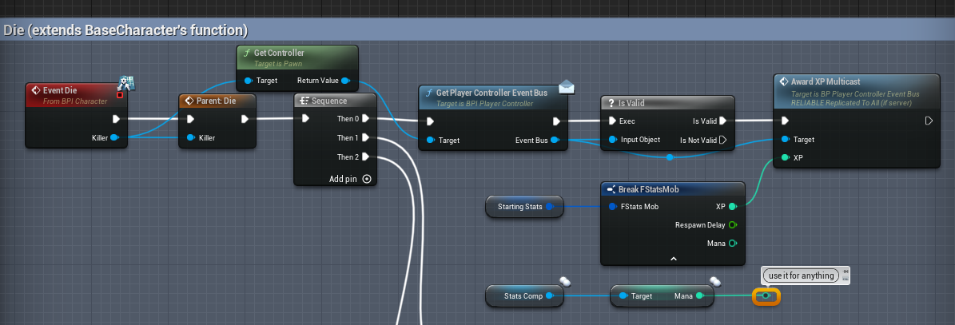

## Inputs

MMO Kit relies on Epic’s [Enhanced Input Plugin](https://docs.unrealengine.com/5.0/en-US/enhanced-input-in-unreal-engine/). There are 4 input configs:

* Universal, which is automatically added on BeginPlay
* FirstPerson
* OverTheShoulder
* WowStyle

One of the 3 latter is added on BeginPlay (specifically in SetupInputControls function), depending on player’s Camera Type:

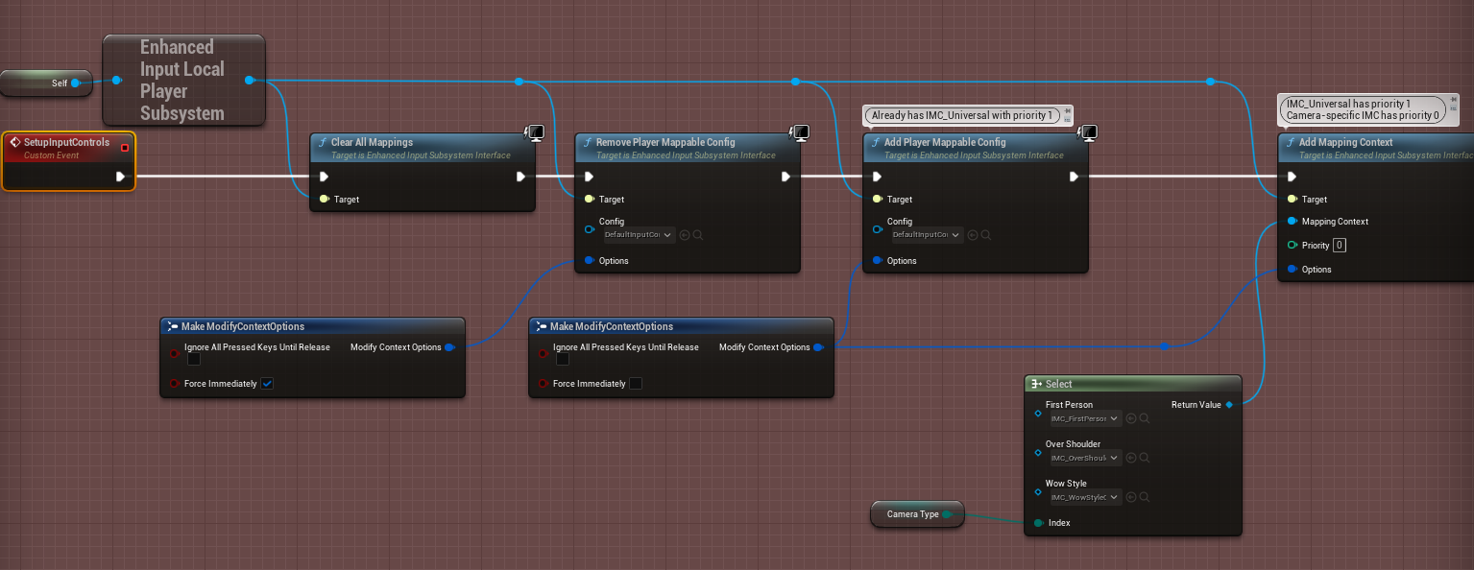

All Input related files can be found in MMO_Logic/InputConfig:

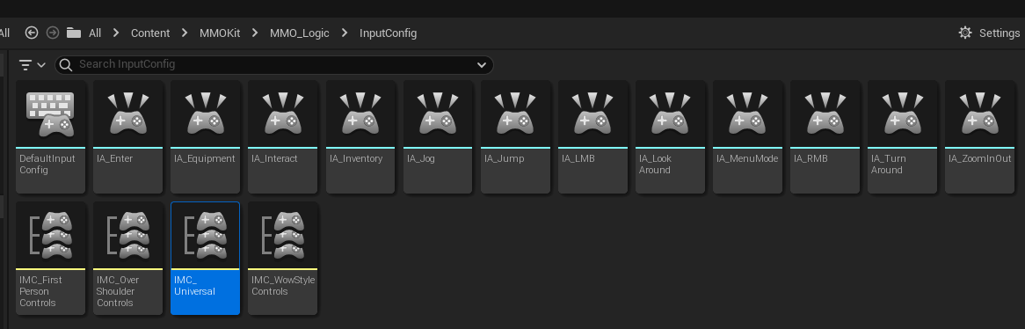

To add a new control, right click -> Input -> Input Action and let’s call it “IA_Fly” for this example.

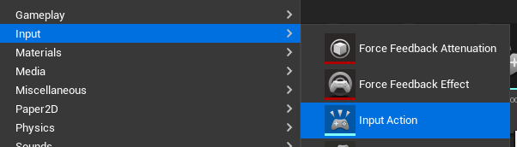

Open IMC_OverShoulderControls and add a mapping for IA_Fly. I’ll map it to the “F” key:

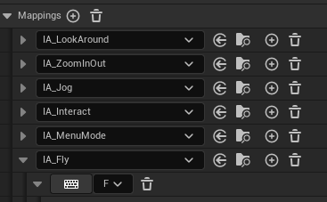

While in this file, notice how IA_LookAround is set up to take its inputs from the mouse or the gamepad:

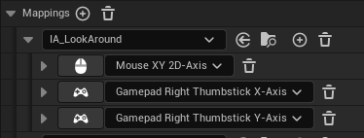

All input is read by the BP_PlayerController and it dispatches events, which other blueprints listen to. All input-related logic is inside this teal comment box:

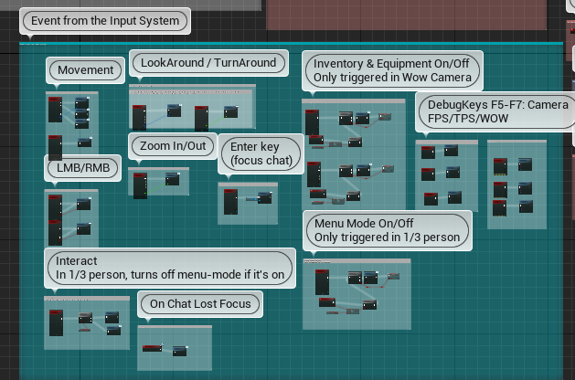

Add a dispatcher event called “OnFly”:

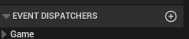

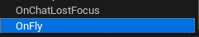

Add the following code:

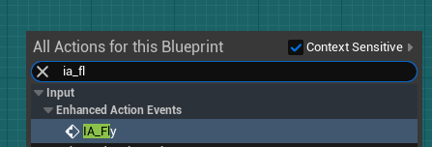

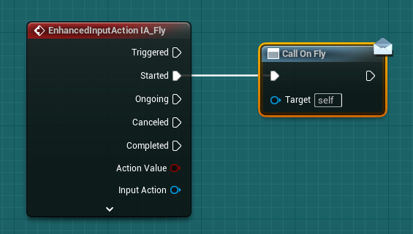

Open BP_BaseCameraComponent, subscribe to PlayerController’s “OnFly” event and create an empty “Fly” event. This is done on BeginPlay:

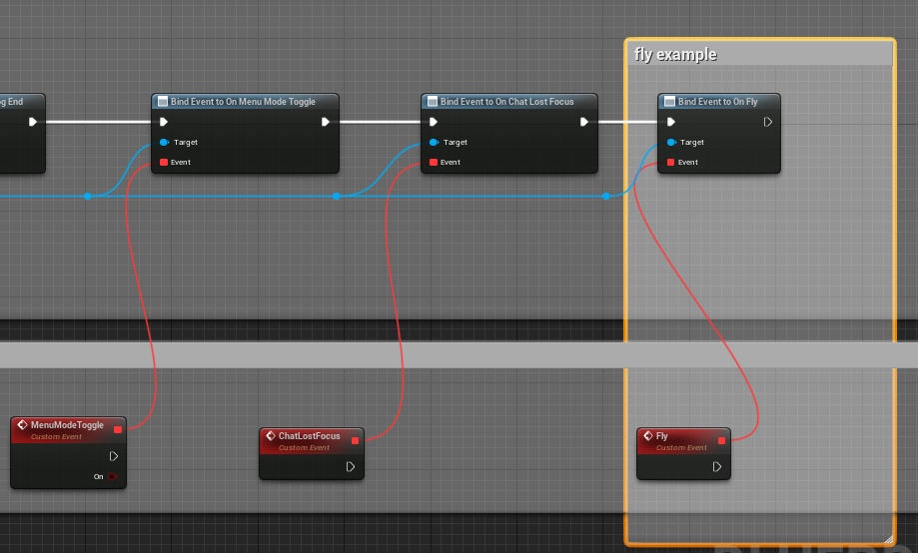

Now all three “camera components” will have a “Fly” event that you can override. Open BP_OverShoulderComponent and write the fly logic:

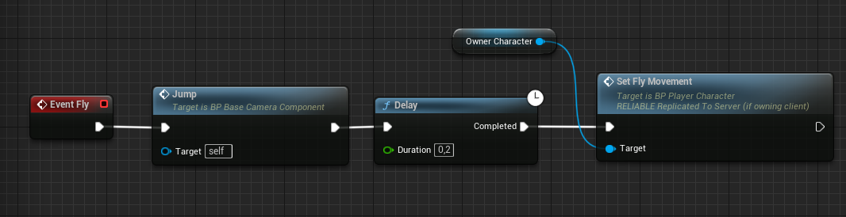

Character’s “SetFlyMovement” function is set to “Run on server” and to be “reliable”, as should be all your replicated functions:

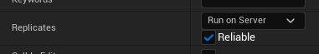

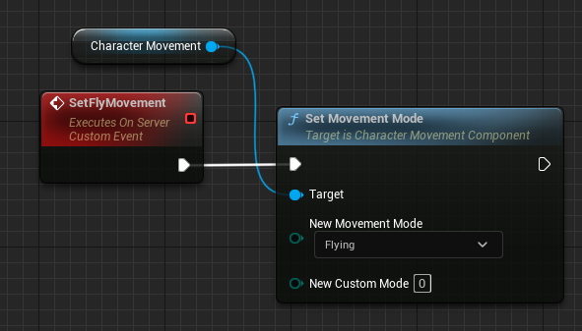

*The reason we don’t try to create a “Server” method in the BP_OverShoulderComponent is because it exists only on Client.*

The result is:

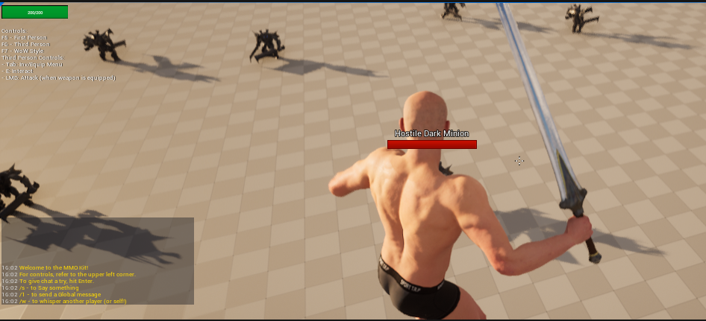

## Interactables

There are 3 examples of interactable objects in the project:

* BP_SwordGiver
* BP_Polymorpher
* BP_SpeciesChanger

They can be found in MMO_Logic/Blueprints/Interaction.

To make a new one, create a Blueprint class inheriting from Actor.

Go to Class Settings and add a BPI_Interactable interface to your class.

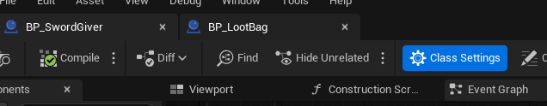

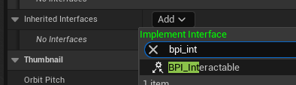

Three functions will become available for you to implement:

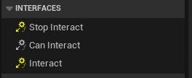

For “Can Interact”, you can just always make it return true for now:

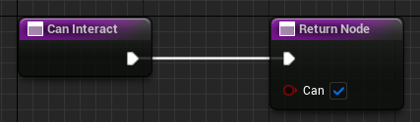

Stop Interact is useful for prolonged actions, like in case of a lootable object. Players observe a container, but “Stop Interact” should be triggered when a) the player moves too far away from it, or b) the container becomes empty because someone has looted it entirely. You can check out **BP_LootBag** for a concrete example.

“Interact” is where the main logic occurs.

BP_SwordGiver’s logic is a fine example with very simple logic:

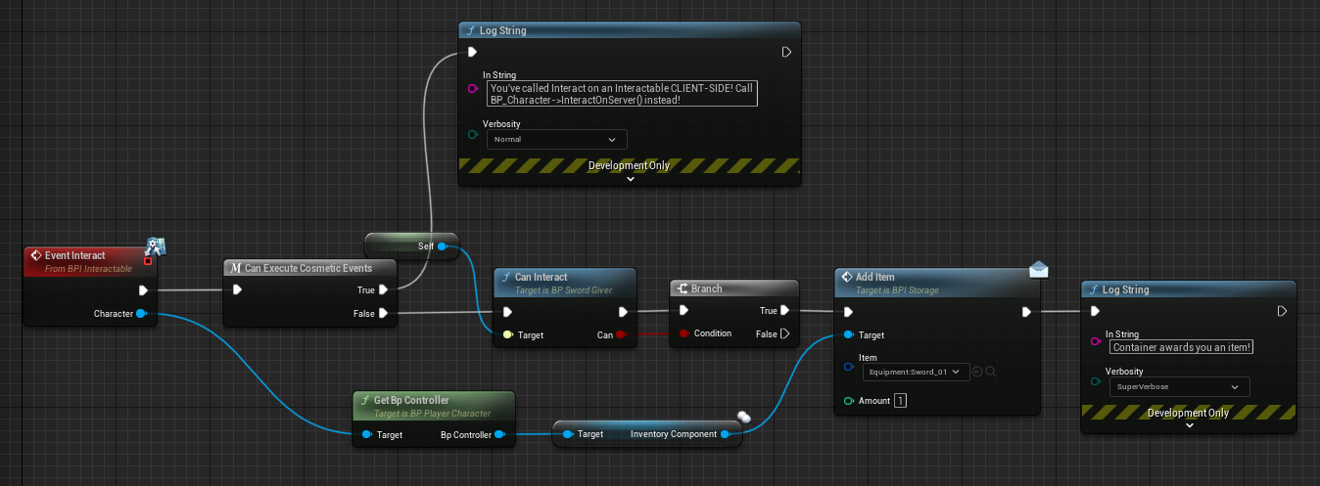

“Can execute cosmetic events” checks for whether we’re on Client or on Server. Since all gameplay is server authoritative, all logic must happen on server.

The “log string” is mostly there to quickly spot any bugs that we may code in.

If we’re on server, we check if we “can interact” and if so, we proceed to give the player an item.

BP_SpeciesChanger is even simpler:

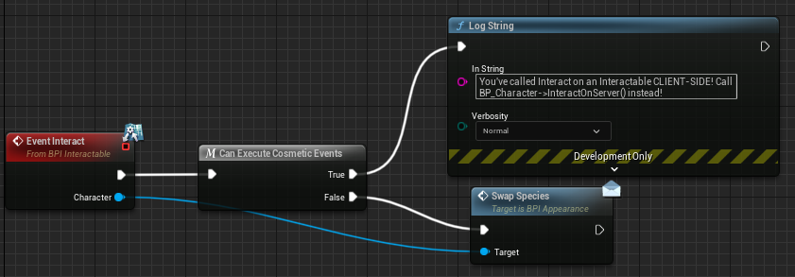

Don’t forget to give your interactable item a mesh:

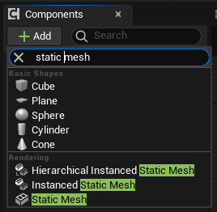

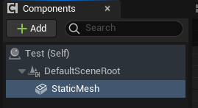

Then go to Collisions and set its preset to either “InteractableBlock” or “InteractablePassThrough”

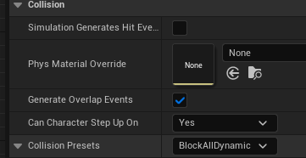

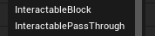

“Block” won’t let players/mobs walk through it, while “PassThrough” will.

If you’re using a mesh that you’ve only recently added to your project, your mesh most likely doesn’t have a collision mesh and will fall through the floor. Open your mesh asset and add a simplified collision:

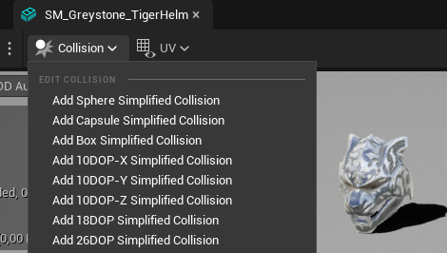

Place the interactable in the world and test if it works.

## World Containers

BP_LootBag is already a functional Interactable object with a BPI_Lootable interface. If you don’t need to modify its functionality, simply create a Blueprint class that inherits from BP_LootBag and change its mesh.

Because TMaps don’t replicate, the loot consists of two arrays, “Loot” and “LootAmounts”:

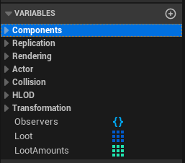

So to add an item to it, you need to add add an element to the “Loot” array, e.g.:

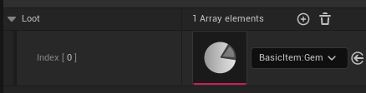

And an element to the LootAmounts array, e.g.:  
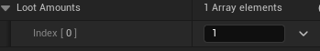

You can make a convenience TMap that would populate the two arrays on BeginPlay, but I didn’t, so as to not overcomplicate things.

You can obviously add any logic to your container, e.g. repopulate it with items once every couple of minutes. Just make sure you modify the variables on the server, e.g.:  
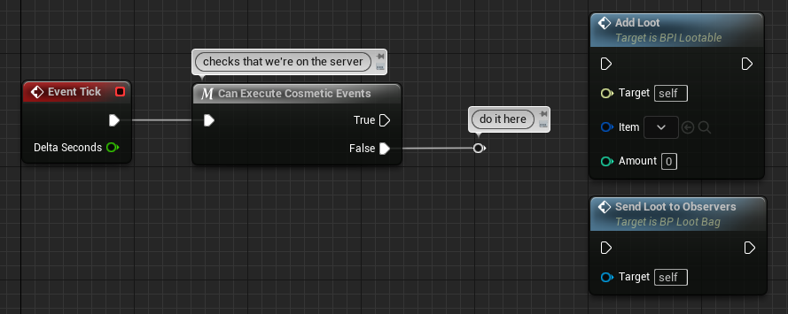

“Send Loot to Observers” should be called when you update the loot arrays. If players have this container open, they’ll immediately see the update.

# Systems

*This section is not yet complete*

## Components

This section shows which components are attached to which actors.

Multilevel inheritance is avoided for clarity.

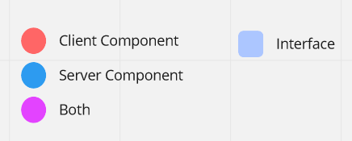

#### PlayerController

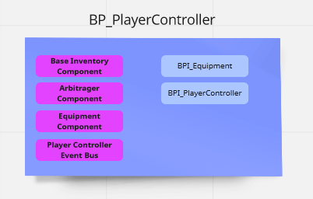

For inventory, the variable is of BaseInventoryComponent type, but it’s the GridInventoryComponent that’s fed into it, so you can easily swap it for your own inventory component:

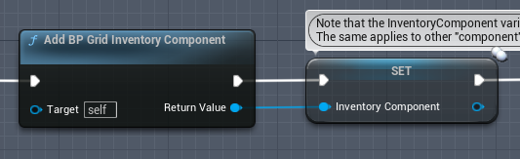

#### Character

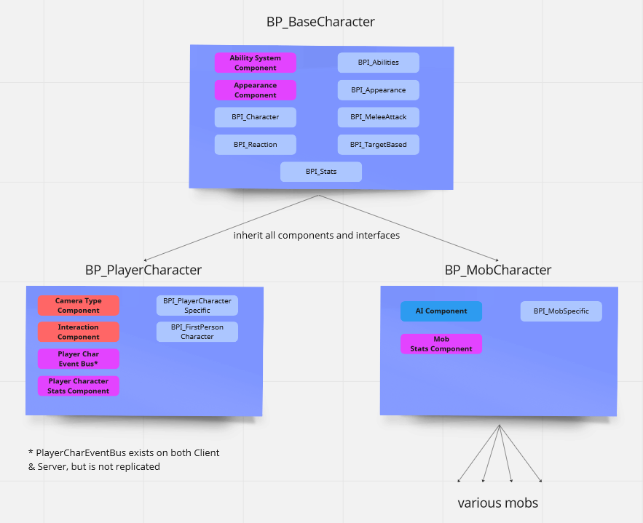

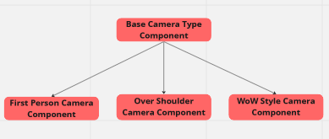 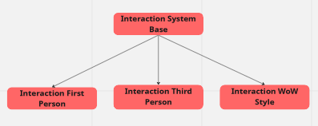

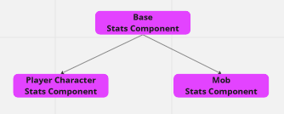

## Game UI

The only widget that gets added to the screen on BeginPlay is **WBP_HUD**, which already has most of UI’s elements on it. It’s added in **BP_PlayerController**’s SpawnHud function.

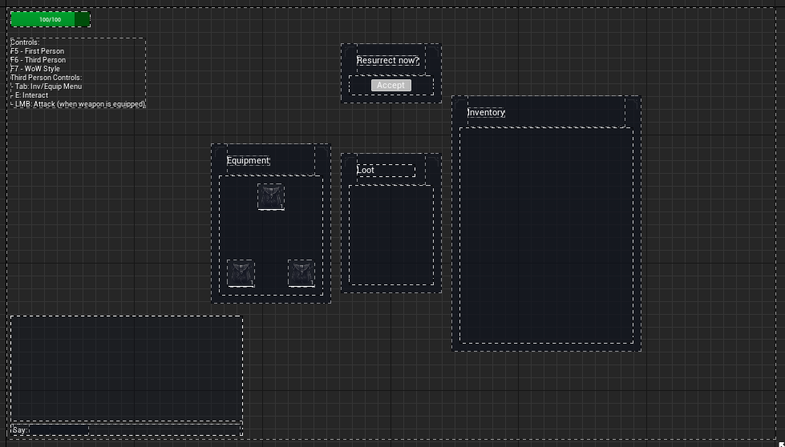

Here’s an overview of main widgets:

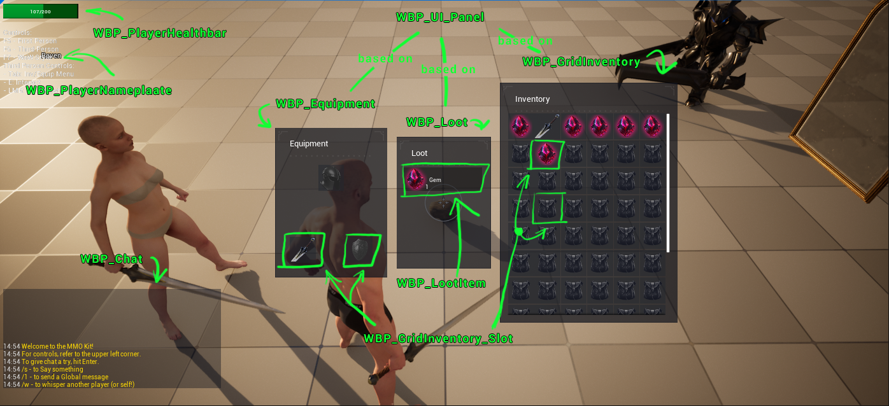

The darkening of screen edges is called a Vignette effect and it’s applied in menu mode from **BP_PlayerCharacter** OnMenuVignette function.

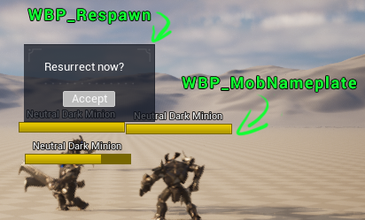

As you may have noticed, most large widgets have decorative corners and the same visual style. This is because they’re based on **WBP_UI_Panel**, which is an empty widget with two named slots: **PanelName** and **ContentSlot**

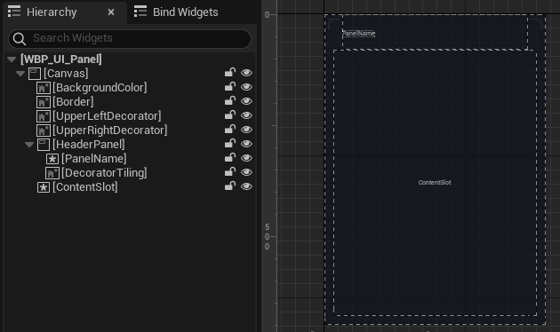

**WBP_Loot** inserts a **WBP_UI_Panel** at the root of its hierarchy and then fills the two named slots with child widgets:

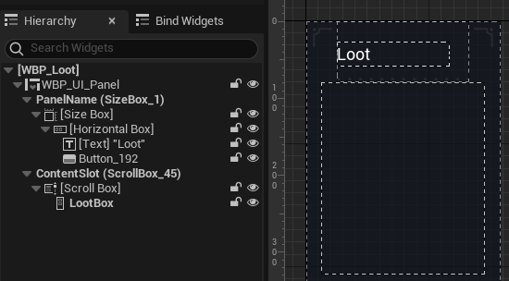

**PanelName** is the first named slot, into which a SizeBox is placed, followed by a test field.

**ContentSlot** has a ScrollBox, into which a VerticalBox is placed.

This is a convenient way of ensuring visual consistency across multiple widgets, though you may choose to do it differently.

Inventory dragged item is represented by **WBP_Dragged_Item**.

## Start UI

**WBP_Start_HUD** contains most of the UI you see on the StartMap:

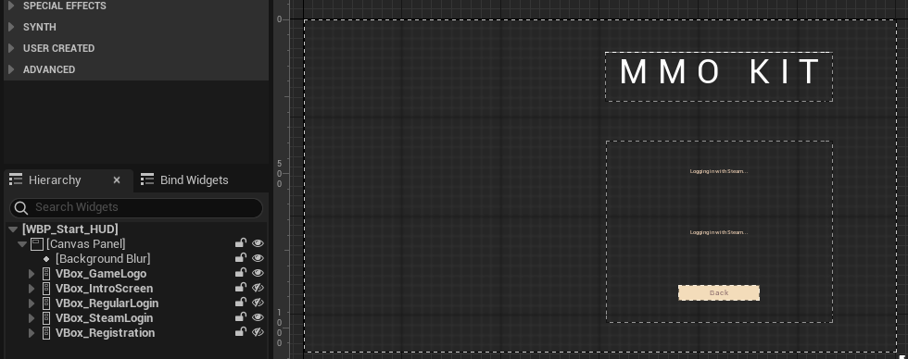

As can be seen on the left, there’s a couple of screens embedded into this HUD.

We start with **GameLogo** and **IntroScreen** on game start.

*Tip: to display these menus, toggle their visibility:*

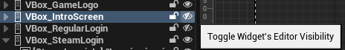

Then we go through **RegularLogin** or **SteamLogin**.

Then BP_Start_PlayerController removes **WBP_Start_HUD** from the screen and adds **WBP_CharSelection**.

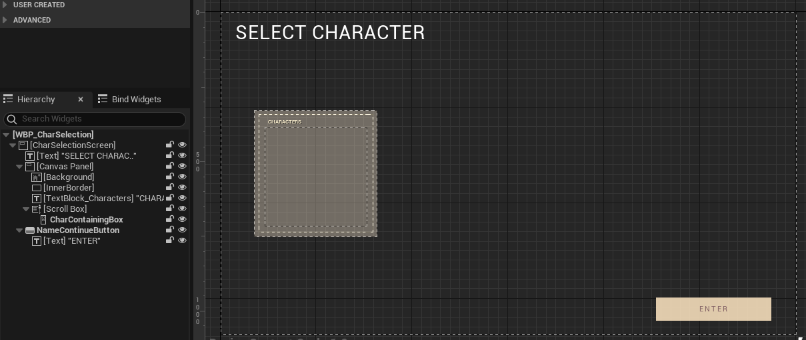

Its **CharContainingBox** is filled with two types of widgets:

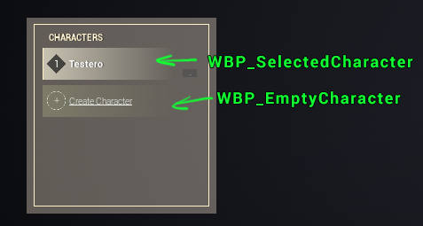

To create a character, we may jump into **WBP_CharCreation**, which itself goes through multiple internal screens much the same way:

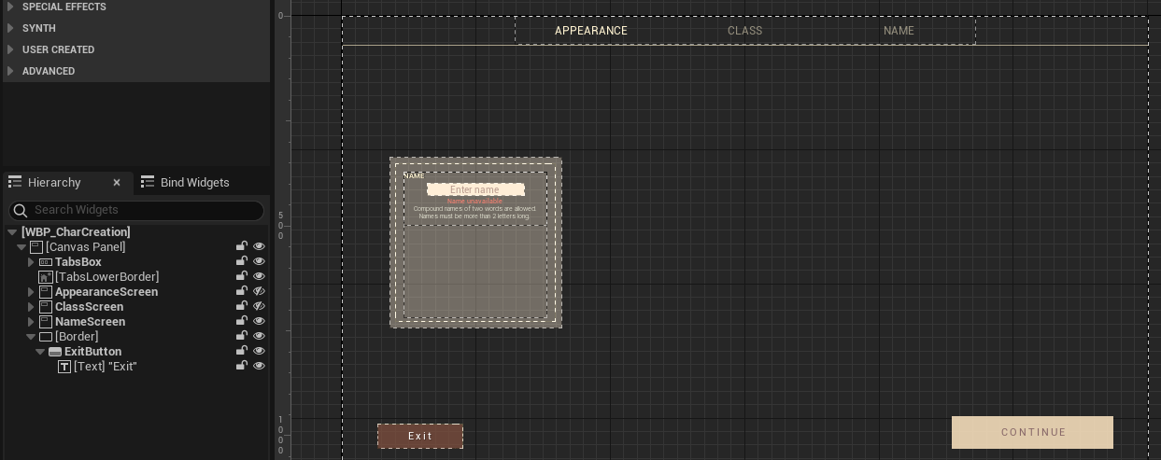

The switch between the three main widgets happens in **BP_Start_PlayerController**

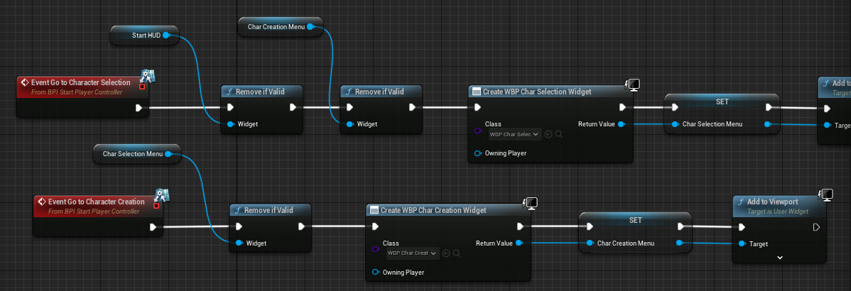

## StartLevel

StartMap is referenced twice in blueprints by name, so if you want to create your own start level, you’ll have to update the name in these two places:

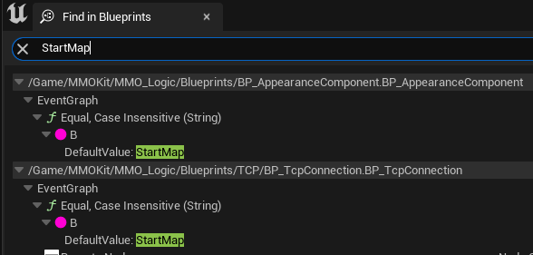

* StartMap has a level blueprint, which sets the camera from which we view the scene.
* Is has a BP_EmptyActor, which determines the position where we’ll spawn the selected character. Under this position, there is an invisible platform, to prevent the character from falling down.
* This level uses a custom gamemode: BP_Start_GameMode (which in turn uses a controller BP_Start_PlayerController).
* This level is set up as default in Project Settings -> Maps & Modes -> Game Default Map

With this information, you can replace this start level with your own.

Another important blueprint used on the StartMap is **BP_CharacterCreationDummy**, which is the character that we see in the Character Selection or the Character Creation screen.

## Camera & Interaction

**BP_PlayerCharacte**r has a variable “CameraTypeComponent” of type **BP_BaseCameraComponent**

and a variable “InteractionSystemComponent” of type **BP_InteractionSystemBase**.

Those two components are added to **BP_PlayerCharacter** on Client only. It’s done in the “SetupComponents” function. E.g.:

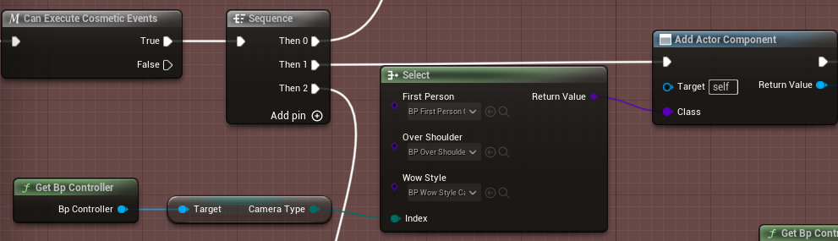

**BP_BaseCameraComponent** subscribes to a lot of PlayerController’s events and creates empty function, which are to he implemented in child classes:

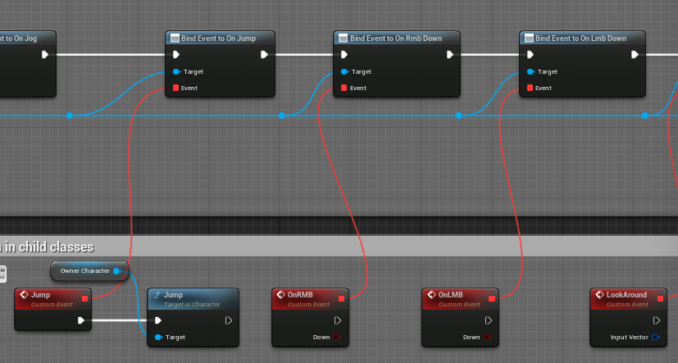

Children of **BP_BaseCameraComponent** are mostly responsible for functionality that is specific to a certain camera type. For example, **BP_FirstPersonComponent** manages the hands mesh, headbob, looking around, etc.

**BP_InteractionSystemBase** emits a couple of events, e.g. OnInteractionUpdated, to which **WBP_Crosshair** is subscribed. Or OnReceivedLoot, to which **WBP_Loot** is subscribed.

Similarly, the three children classes of **BP_InteractionSystemBase** implement the interaction system in their own ways. First Person and Third Person mostly do a line trace forward from the camera on Tick, while WoW-style looks for an interactable under the cursor on Right Click.

## AssetManager & DataAssets

*Note: this section is for advanced users, beginner users can skip it entirely*

### Asset Manager

Abilities, Items and CreatureAppearances are PrimaryDataAssets. [Primary assets](https://docs.unrealengine.com/5.1/en-US/asset-management-in-unreal-engine/) aren’t loaded into memory automatically, and aren’t even packaged automatically.

To package them, they’re already set up in the Asset Manager settings:

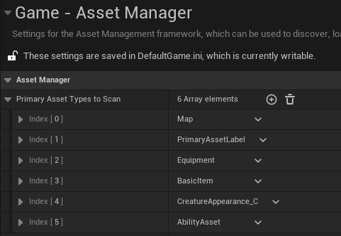

It’s a bit of a circular logic, but the Primary Asset Type that we create here, by typing in a string:

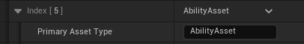

… is what we need to return as “Asset Type” inside all primary data assets. E.g. all abilities need to have their asset type set to AbilityAsset:

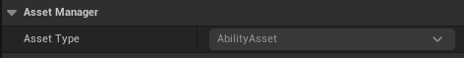

This is because AbilityAsset inherits from AbilityAssetCpp, where we need to override GetPrimaryAssetId(). Which is done like as follows. In .h:

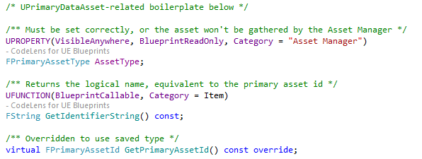

In .cpp:

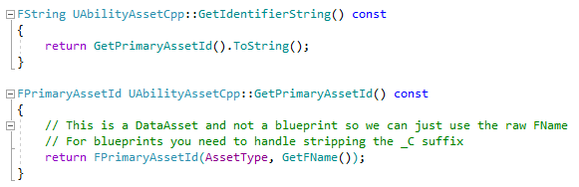

You don’t need to worry about any of it, this is just an explanation of how it’s set up.

To sum up, if you create new types of items by inheriting from ItemAsset, the assets need to return the type that you set for them in the Asset Manager. For example, you create a type “TestItem” in the asset manager:

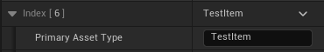

Then your new item type has to return it here as asset type:

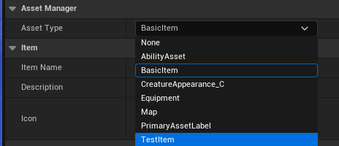

However, if you create blueprint classes that inherit from UPrimaryDataAsset, then the name in the Asset Manager must correspond to the type with a _C suffix.

A working example of it is **CreatureAppearance** class. Its asset type in the Asset Manager has to be CreatureAppearance_C to work, because this is what UPrimaryDataAsset returns in GetPrimaryAssetId() when it’s not overridden.

### Asset Loading

#### Server

All custom primary asset types (BasicItems, Equipment, AbilityAsset, CreatureAppearance_C) are loaded on BeginPlay in **BP_GameMode** and stay referenced for the duration. This is why it’s important to soft-reference meshes, textures and other heavy assets in those Primary Asset Types. E.g. equipment has a soft reference to a static mesh & a skeletal mesh. This way, the server won’t have to load those meshes into memory.

#### Client

The client will load all AbilityAssets into memory on BeginPlay in **BP_PlayerState** and will keep them in memory for the duration of the game.

CreatureAppearance_C and Equipment assets will be loaded asynchronously on demand by the **BP_AppearanceComponent**, see Appearance.

BasicItems (and Equipment) will be loaded asynchronously on demand by **WBP_LootItem** after receiving a loot update or by **WBP_GridInventory_Slot** after receiving an Equipment/Inventory update.

## TCP Connection

Unreal is connected to Persistence Server by a TCP socket connection, relying on [TCP Socket Plugin](https://www.unrealengine.com/marketplace/en-US/product/tcp-socket-plugin) (by the authors of MMO Kit), which has been integrated into MMO Kit Code Plugin.

**BP_TcpConnection** is spawned in two places:

* **BP_Start_PlayerController** on BeginPlay - connects the client to Persistence Server while on the StartMap
* Once we transition to the LargeMap, the connection is lost, because no actors survive the transition, so we spawn it again in **BP_GameState** on BeginPlay. UE5 game severs start on LargeMap, so they spawn a TCP connection on BeginPlay, too.

### Server

The server logs in by sending an RPC with the “server password”, which is set in MMO Kit Code Plugin in GameModeBaseCpp.h:

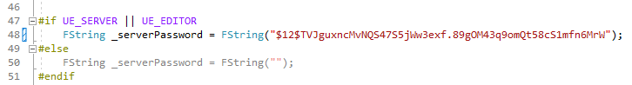

By using the macros, we ensure that the Client build doesn’t have this password in its code.

On Persistence Server, this password is set in the .ini file.

You are strongly encouraged to change this password in both places before making a public release of your game.

### Client

The client logs in on the StartMap by either sending login + password, or by sending its Steam ID + Auth Ticket. If the login is successful, the client receives a cookie, which it saves on GameInstance. GameInstance is the only class that survives the transition from one map to another.

Upon reconnecting from the LargeMap, we send our character ID and the cookie to log in the second time.

In the Editor, since we’re connecting immediately from the LargeMap, bypassing the first login procedure, we use a “UniversalCookie”, which is set in GameInstanceCpp.h:

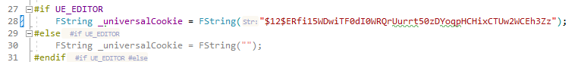

The macro ensures that this cookie nevers gets distributed to Clients.

Still, since all MMO Kits are shipped with the same cookie, you are encouraged to change it before making public releases.

On Persistence Server, this cookie is stored in the .ini file.

**Note** that the Persistence Server allows connecting using this cookie only in Debug configs.

If you build Persistence Server in the Release config to test with the Editor, it will not work.

How UE5 “talks” with Persistence Server will be explained in the section on RPCs.

## Persistent Server (C#)

#### RPCs

UE5 and Persistent Server communicate through a very simple protocol. Each message is prefixed with a byte that tells you which type of message this is.

In C#, it’s an enum RpcType in RpcTypes.cs, in UE5 it’s an enum ERpcType.

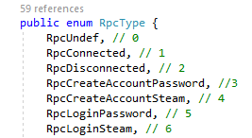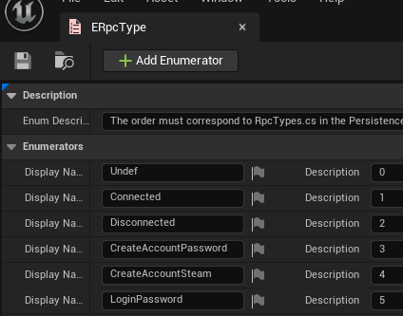

The two enums must always be the same.

In C#, whenever a message is received, it will be processed by one of the classes in the RPCs folder:

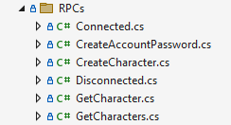

Let’s look at one of the RPCs to see how they work:

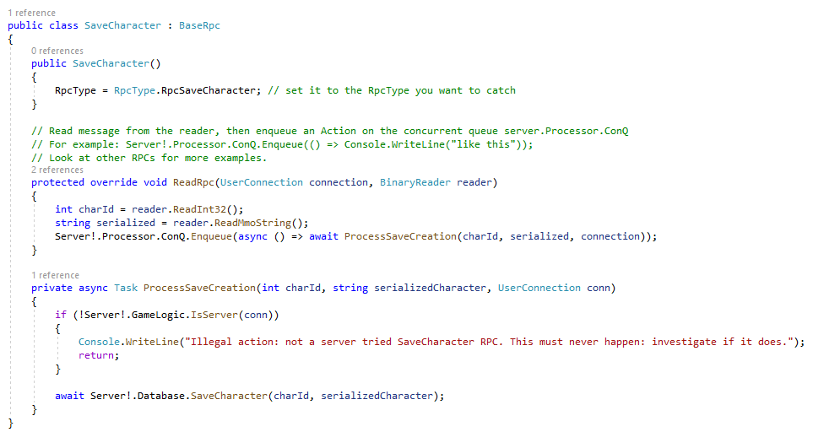

1. In order for a class to intercept a message, it must set its RpcType correctly.
2. When a message is intercepted, ReadRpc() will trigger. In it, we must read some variables from the buffer. It’s the same variables that we serialized in UE5, see BP_TcpConnection -> SaveCharacter function: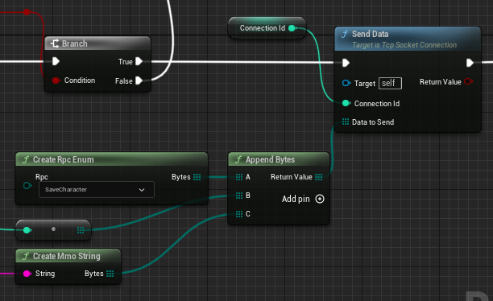

As you can see, we serialize: **[RpcType] [an integer] [a string]**

So deserialization in C# must be done in the same order: ReadInt32() and ReadMmoString().

1. Because each connection works on its own thread in C#, we must synchronize (put on the main thread) the logic triggered by the message. To do this, we have to use some boilerplate in the form of Server!.Processor.ConQ.Enqueue( [your logic] ). You can look at other RPCs for examples of usage.

To see an example of how to send data back from C# to UE5, see GetIpAndPort.cs, which is a 3-line method:

byte[] msg = MergeByteArrays(

ToBytes(RpcType.RpcGetIpAndPort),

ToBytes(true),

ToBytes(123),

WriteMmoString("test")

);

connection.Send(msg);

The logic here is the same: prepend the RPC byte, followed by whatever message you want to send, also in bytes.

There are convenience methods to convert integers, floats, bools, strings to bytes. For strings, it’s WriteMmoString(), for the rest it’s ToBytes().

Then in UE5 we read messages in BP_TcpConnection -> OnMessageReceived:

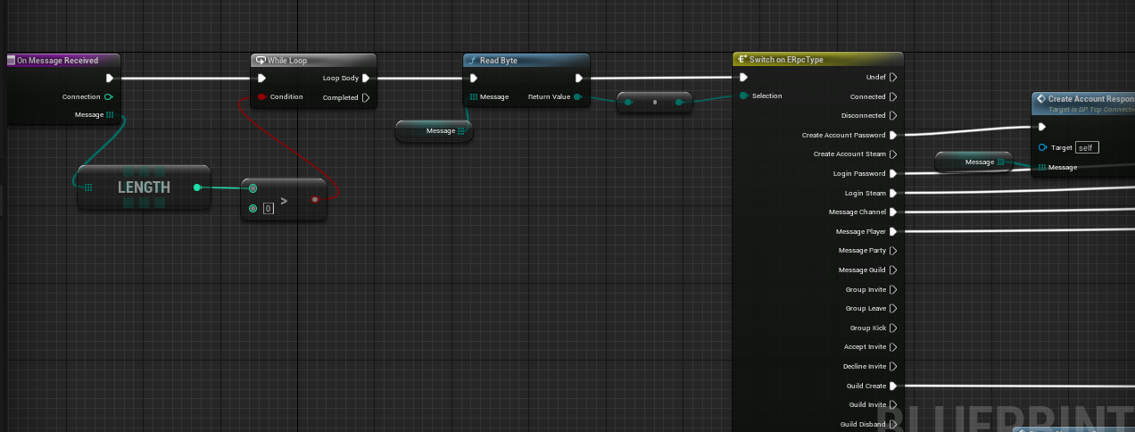

We read one byte to determine the RPC type, then switch on it.

By calling the Read methods, we take information off the buffer, which allows us sequential reading.

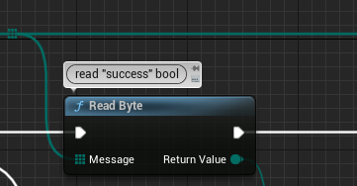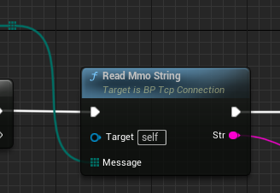

**Caution**: don’t use “ReadString” method in UE5, only use “**ReadMmoString**”:

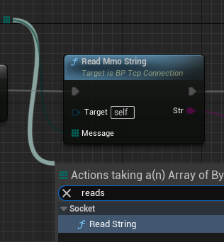

This is because we always pack a string as follows: [an integer for the length of string] [the string itself]. **ReadMmoString** takes care of that convention. In C#, also use ReadMmoString().

All functions that send or receive things in UE5 are located in BP_TpcConnection under Send/Receive categories:

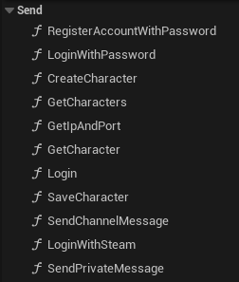 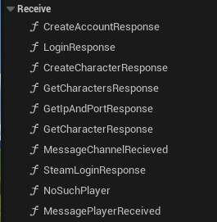

It makes sense to often reuse the same RPC type for two different purposes. For example, when UE5 sends a “Login” message, it sends login & password. Then C# returns the a message with the “Login” byte, but the response is a cookie. It would make no sense to send a cookie with the “Login” byte, but let’s say we’re lazy and don’t want to create a “Cookie” RPC, so we repurpose an RPC byte for a response instead.

If you want to create a new type of message between UE5 and C#, do the following:

* Create an enum on both ends
* In C#, create a class in the RPCs folder inheriting from BaseRpc
* In UE5, create a function and hook it up in **OnMessageReceived** method.

For convenience, I’ve created a C# template, which you can download [here](https://drive.google.com/file/d/1W8ymGbtD8IpsT2snwWxtQFTkxKQ8Y1Av/view?usp=share_link) and place (as is, without unzipping) in:

*C:\Users\****<user name>****\Documents\Visual Studio 2022\My Exported Templates*

Then creating an RPC class is a matter of two clicks:



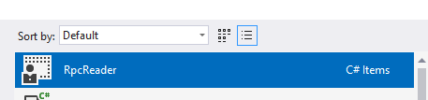

This will take care of the boilerplate for you, all that remains is setting RpcType to the correct type, and then reading your variables in ReadRpc.

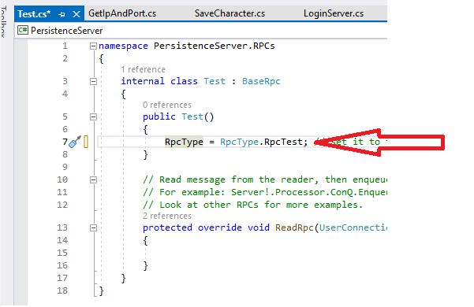

## MySQL/SQLite Database

SQLite database can be inspected in the [DB Browser](https://sqlitebrowser.org/), MySQL can be inspected in phpMyAdmin.

Persistence Server creates the database on startup if it’s not found. In Debug config, you’ll find it at \PersistenceServer\bin\Debug-Sqlite\net6.0\mmokit.db

In release builds, it should be placed at the same path as the built executable.

The syntax is slightly different between SQLite and MySQL, both instructions on db creation can be seen in DatabaseMysql.cs and DatabaseSqlite.cs, in the CheckCreateDatabase() method, e.g.:

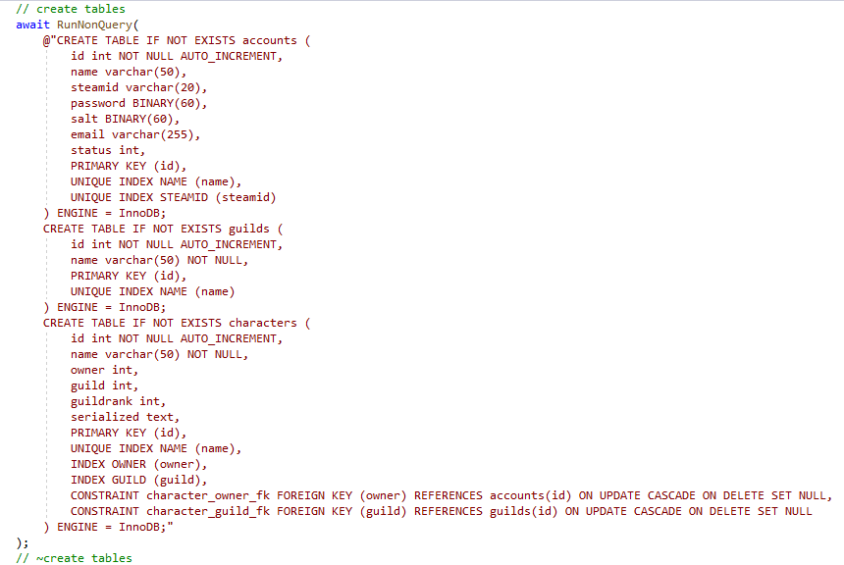

As you can see, there’s only 3 tables. Here’s how they look in DB Browser:

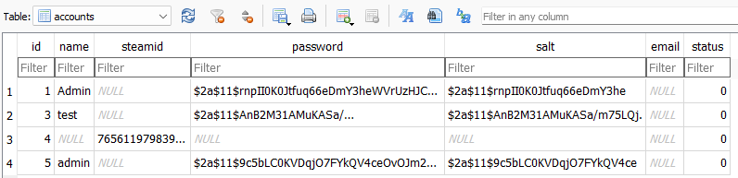

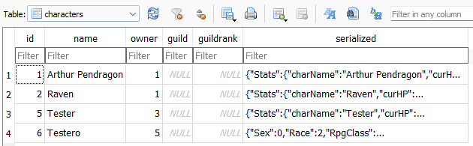

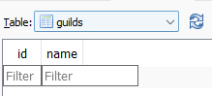

*(no guilds yet)*

The foreign key constraints are there to prevent any db corruption due to manual manipulation, so if for example you delete a guild, the “guildID” in all guild members will be set to null. If you delete an account, all characters will have their “owner id” set to null and won’t accidentally end up belonging to another account.

As you can see in DB Browser, player characters are serialized as JSON:

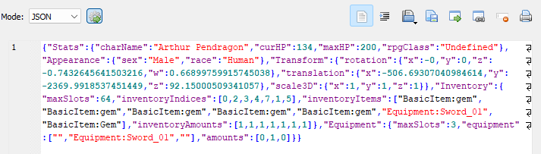

You can use one of the many online JSON viewers, such as <http://jsonviewer.stack.hu/> to inspect a character more easily:

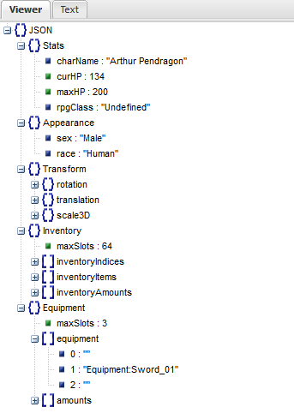

### MySQL

Since non-privileged accounts can’t create a database, you may need to create one manually. If this is your case, use utf8mb4_0900_as_ci if you need an accent sensitive collation, utf8mb4_0900_ai_ci otherwise.

*Note: the current version of Persistence Server doesn’t know how to deal with a manually created MySQL database, this will be addressed in the next update or see* [*this message*](https://ptb.discord.com/channels/1044256330208247849/1044663498673762354/1062391191771037716) *for a quick fix.*

## Login

With Steam:

* When a player launches the client, it connects to Persistence Server and sends two things: its steam id and its Steam Auth Ticket. See *LoginWithSteam.cs.*
* Persistence servers checks the ticket by sending it to Steam API. If the validity of the ticket is confirmed, Persistence Server sends a list of characters back AND a freshly generated cookie.
* The client selects a character he wants to play with, saves it into GameInstance and connects to UE5 Game Server.

With Login/Password:

* Same procedure, but the client sends Login and Password, and the Server checks against what’s stored in the database. See *LoginWithPassword.cs*
* The rest is the same as with Steam.

When a player connects to a UE5 server, the server normally spawns a character for the player and replicates it to him through this sequence of functions:

* GameModeBase::HandleStartingNewPlayer or SpawnPlayerFromSimulate or other
* GameModeBase::RestartPlayer
* GameModeBase::RestartPlayerAtPlayerStart <- this is what we’ll interrupt
* GameModeBase::SpawnDefaultPawnFor
* GameModeBase::FinishRestartPlayer

MMO Kit Code (the C++ plugin) overrides RestartPlayerAtPlayerStart and calls APlayerControllerCpp->CustomPlayerStart(), which is a BlueprintImplementableEvent.

The server asks the client for its cookie and char id.

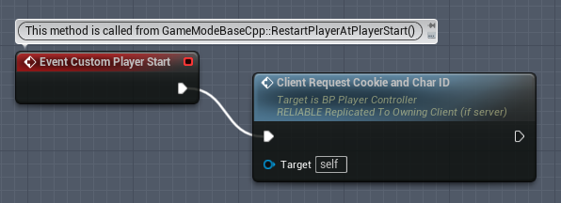

Once the player answers, the UE5 server requests a character from Persistence Server, which in turn requests it from the DataBase.

Once UE5 server has the character’s parameters, it spawns the character in **BP_PlayerController**::SpawnCharacter:

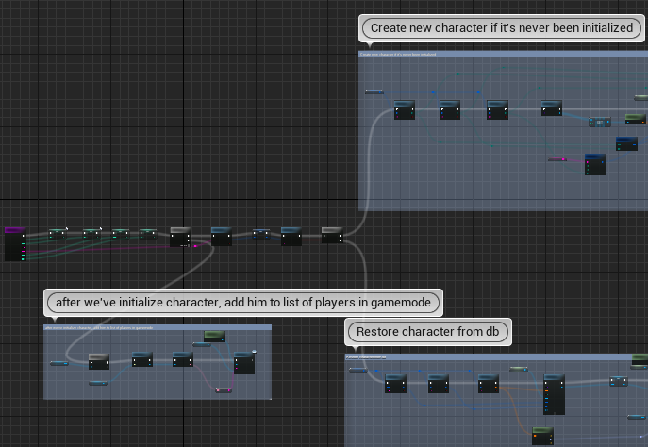

Once the character has been spawned, we turn control over to UE5’s standard login sequence by calling GameModeBase::ContinuePlayerStart, which will in turn call FinishRestartPlayer.

## Logout

When the player leaves the game, BP_PlayerController’s **OnUnPossess** event is triggered on the server, from where the character is serialized and saved to DB. The serialization is done in BP_PlayerController::**SaveCharacter**.

In Editor, the entire world gets destroyed too fast for **OnUnPossess** to save characters, because the TCP connection will be destroyed beforehand. To circumvent the problem, MMO Kit Code subscribes to FEditorDelegates::EndPIE and emits an **OnEndPIE** event in BP_GameMode.

## Inventory

(and how to create new items + new types of stats)

## Loot

## Equipment

(and how to create new equipment slots)

## Appearance

## Mobs

(and how to make new mobs)

## AI

(and how to make new AI BTs)

## Abilities

(and how to make new Abilities with examples)

## Stats

## Animations

(compatible skeleton, IK retargeters, using BasicMap to create new animations...)

# Widgets

*This section is not yet complete*

# Building a deployable dedicated server and client

Unreal Engine from Epic Launcher can’t build Clients and Servers. Hence, you’ll have to download UE5 sources and rebuild the engine manually.

You’ll also need to convert MMO Kit from a blueprint project into a C++ project. This is a technicality, you don’t need to know C++.

### Prerequisites

Install [.Net Runtime](https://dotnet.microsoft.com/en-us/download/dotnet/thank-you/runtime-3.1.32-windows-x64-installer?cid=getdotnetcore).

Install the latest Visual Studio Community. During installation, select the following components:

* .NET desktop development
* Desktop development with C++
* Universal Windows Platform development
* Game development with C++
* Linux and embedded development with C++

*Please understand that producing a list of installation requirements is difficult, since it would require to wipe the OS clean and start anew with every new UE5 release, hence this list may not be comprehensive. If you find yourself unable to compile the project with the selected components, refer to* [*Epic’s guide to Visual Studio*](https://docs.unrealengine.com/5.0/en-US/setting-up-visual-studio-development-environment-for-cplusplus-projects-in-unreal-engine/) *and be sure to select your engine version, though their guide is often out of date.*

Compile UE5 from Github sources. <https://github.com/EpicGames> You will need to link your Github account with your Epic account, which will grant you access to [UE5 sources](https://github.com/EpicGames/UnrealEngine). Their README contains a good guide on how to build the engine.

### Adding Build Targets

Unreal Engine can build dedicated server [only from C++ projects and from Git engine](https://docs.unrealengine.com/4.27/en-US/InteractiveExperiences/Networking/HowTo/DedicatedServers/). Turn your Blueprint project into a C++ project by creating an empty C++ class.

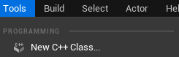

This will create two targets in the /Source/ directory: MMOKit.Target.cs and MMOKitEditor.Target.cs.

To add Client & Server targets, get them from **/ProjectRoot/AdditionalFiles/CSharpTargets.zip** and place them into the **/ProjectRoot/Source/** folder.

### Adding the Plugin

Create a “Plugins” folder in the root of the project. Copy MMOKitCode plugin from Launcher Engine (Engine\Plugins\Marketplace) into the project’s “Plugins” folder, so as to have Plugins/MMOKitCode/MMOKitCode.uplugin.

### Building the Editor

Right click on the MMOKit.uproject, select “Switch Unreal Engine version” and select your Git engine:

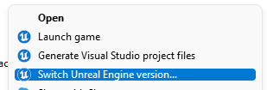

Open MMOKit.sln in Visual Studio, right click on the project (not solution!) and select **Build**:

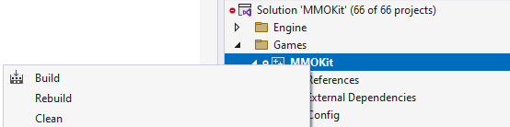

With a Git engine, this may take up to an hour.

Once the output says “build complete”, open the project in UE5.

### Building the Project

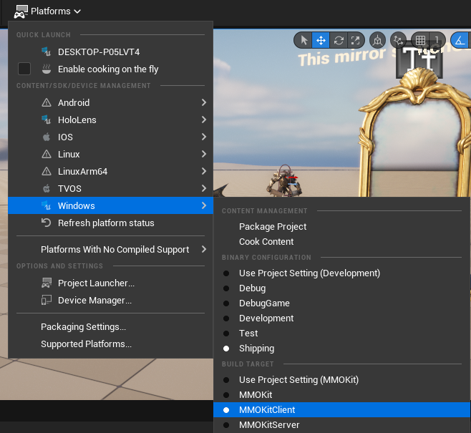

Platform -> Windows -> check “Shipping” if you intend to distribute it, or “Development” if it’s for debugging purposes.

Platform -> Windows -> check “MMOKitServer” and hit “Package Content”, then allow it to build

Platform -> Windows -> check “MMOKitClient” and hit “Package Content”, then allow it to build

Now you have a server and a client. To test them, create a shortcut for MMOKitServer.exe and add parameters: -log -NOSTEAM -local

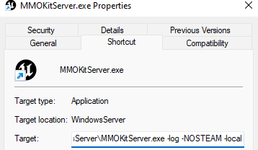

-NOSTEAM is always necessary for the server

-local means your server will try to connect to the Persistence Server on 127.0.0.1

For the client, use: -log -local

IMPORTANT: If you’re testing a Steam client locally and it’s in Shipping configuration, put a steam_appid.txt file next to its executable with your game’s steam id or 480 if you don’t have one yet (the file goes into WindowsClient\<ProjectName>\Binaries\Win64). This is for local testing only, you **must** delete this file before deployment to Steam.

Any other configuration, e.g. Development, does not require this step.

If you don’t add this file in Shipping configuration, the game will fall back to OnlineSubsystemNull and will display a regular password based login menu.

## Persistence Server

To build Persistence Server for Windows or Linux, right click on your project in Visual Studio and select “Publish”.

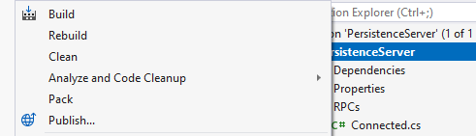

Deploy to a folder, select Deployment Mode: *Self Contained* and Target Runtime: *win-x64* or *linux-64*. For production deployment, always select “Release”. This will be the result:

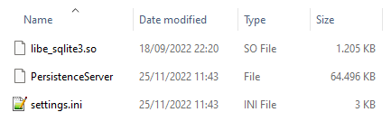

If you want to keep using the same sqlite db you were using in debug mode, feel free to copy it here from \PersistenceServer\bin\Debug-Sqlite\net6.0\mmokit.db.

Upload these files to your linux machine and mark the large file as executable in chmod. For Windows, it works out of the box. Now you can run it.

# Steam integration

[Set up unreal](https://docs.unrealengine.com/5.1/en-US/online-subsystem-steam-interface-in-unreal-engine/):

Skip “Downloading steamworks” and “Compiling UE4”

Follow “Setting up the Steamworks SDK” instructions. Skip everything else.

Open your project’s Config/DefaultEngine.ini, uncomment lines 10 through 22:

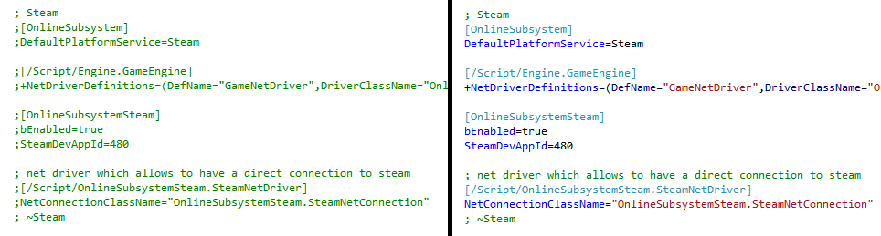

Replace **SteamDevAppId** with your game’s steam id.

In MMOKitClient.Target.cs, uncomment the line: //bUsesSteam = true;

Tip: when you want to go back to building non-steam builds, simply comment back out the two files. Use “git stash” to easily switch between the two versions.

Rebuild the project in Visual Studio (full rebuild! It will rebuild the engine, too) . Only then will the Editor will start packaging Steam builds.

### Persistence Server

Now let’s get your Publisher Web Api Key. Login to Steam Partners, in the top panel click on “Users & Permissions”, you’ll see a list of users - click on yourself, you’ll see a group - click on it, in the right column you’ll see “Create WebApi key”, click it and it’ll appear. Copy it into Persistent Server’s settings.ini into the ‘SteamPublisherKey’ setting.

This is a private key that you shouldn’t share with the public, but can share with the development team.

You also need to put your app id into Persistent Server’s settings.ini

Now when you build a client, it’ll launch with Steam overlay and you won’t be able to launch more than one, even for debugging purposes. Building a Shipping configuration and not placing the steam_appid.txt next to its root should allow you to launch multiple instances, since Steam initialization will fail and they’ll fall back to OnlineSubsystemNull (haven’t tested it yet, let me know how it goes).

In PIE, you’ll still be on the OnlineSubsystemNull, so no Steam there.

## Upload a build to Steam:

Download the latest Steam SDK from <https://partner.steamgames.com/home>

You’ll need it to upload builds. Specifically we’ll use steamcmd.exe, which has ample documentation here: <https://developer.valvesoftware.com/wiki/SteamCMD>

Deployment on a real server:

Fill in the IP with Persistence Server IP in “B”:

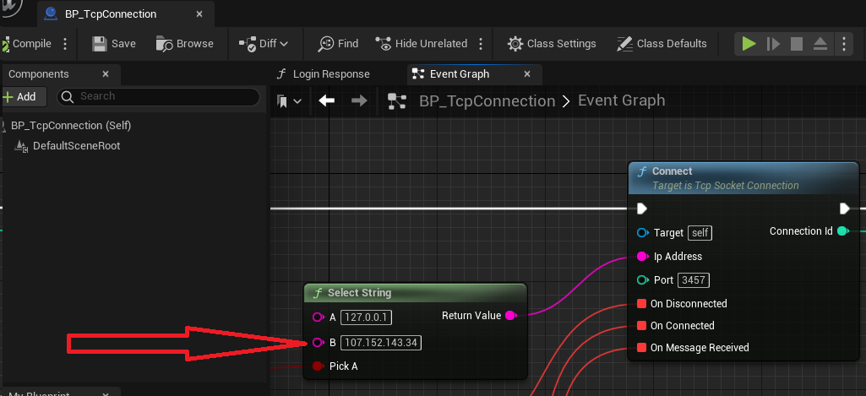

Build Persistence Server in Release mode, open settings.ini and fill the GameServerIP field. In my case, it’s also 107.152.143.34, because both Persistence Server and Game Server are hosted on the same physical server.

Go into steam depots and find the depot id. On the screen below it’s 2090871:

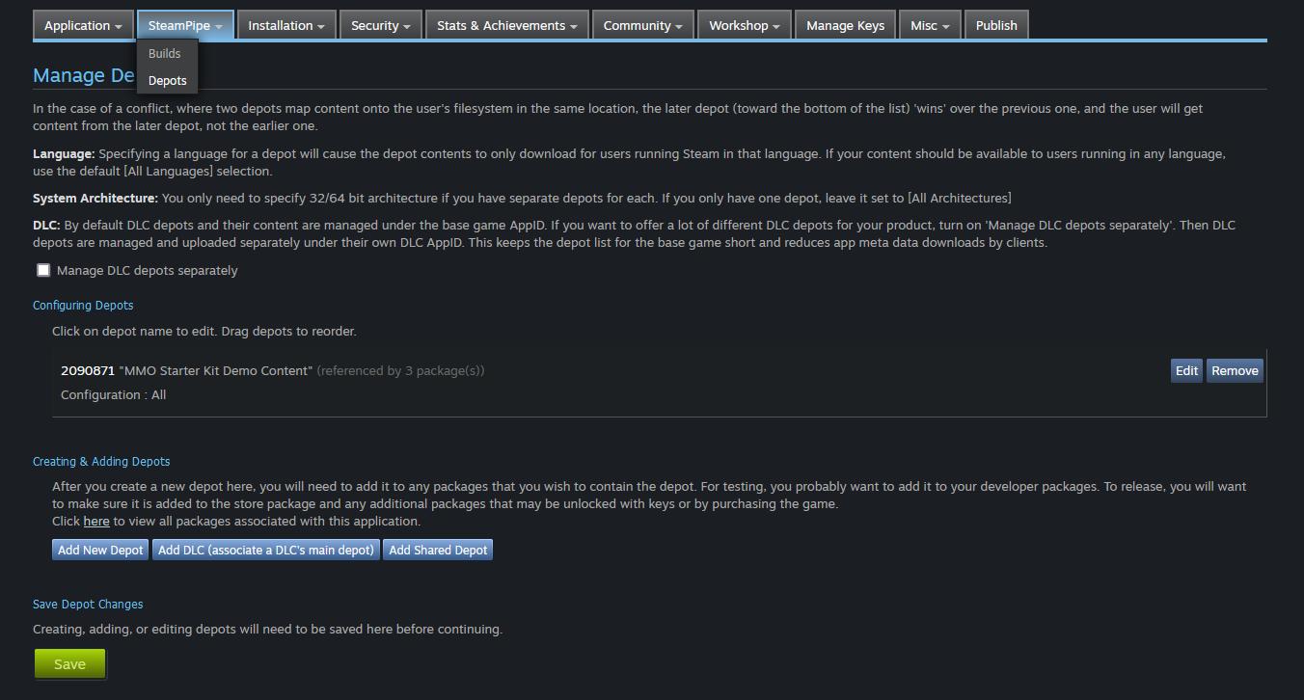

Go into SteamSDK/sdk-your-version/tools/ContentBuilder and copy run_build.bat. Call the copy upload_mmo_client.bat, change its content to:

builder\steamcmd.exe +login **your_steam_login your_steam_password** +run_app_build ..\scripts\normal-client.vdf +quit

Replace “your_steam_login” and “your_steam_password” with your values.

TIP: to avoid entering the Steam Guard code every time, you can create a second account that you’ll use for deployment only, and turn off steam guard in its settings. This should be an administrative account. You can do it later, once the entire setup works, for now do it with your main account. After uploading, your Steam will go offline, so relaunch it (otherwise you may fail to launch your Steam client in testing mode, for example).

Go to /scripts/ and copy simple_app_build.vdf, call it normal-client.vdf and change its contents to:

"appbuild"

{

"appid" "2090870"

"desc" "Normal client build" // description for this build

"buildoutput" "..\output\" // build output folder for .log, .csm & .csd files, relative to location of this file

"contentroot" "..\content\" // root content folder, relative to location of this file

"setlive" "" // branch to set live after successful build, non if empty

"preview" "0" // to enable preview builds

"local" "" // set to file path of local content server

"depots"

{

"2090871" "depot_build_2090871.vdf"

}

}

Change 2090870 to your APP ID, 2090871 to your DEPOT ID, and change the “depot_build_…vdf” file name accordingly. Now copy depot_build_1001.vdf and rename it to “depot_build_…vdf”, then change its content to:

"DepotBuildConfig"

{

// Set your assigned depot ID here

"DepotID" "2090871"

// Set a root for all content.

// All relative paths specified below (LocalPath in FileMapping entries, and FileExclusion paths)

// will be resolved relative to this root.

// If you don't define ContentRoot, then it will be assumed to be

// the location of this script file, which probably isn't what you want

"ContentRoot" "D:\MMO_Kit_Creation\Build\WindowsClient\"

// include all files recursivley

"FileMapping"

{

// This can be a full path, or a path relative to ContentRoot

"LocalPath" "*"

// This is a path relative to the install folder of your game

"DepotPath" "."

// If LocalPath contains wildcards, setting this means that all

// matching files within subdirectories of LocalPath will also

// be included.

"recursive" "1"

}

// but exclude all symbol files

// This can be a full path, or a path relative to ContentRoot

// "FileExclusion" "*.pdb"

}

Change DepotID and ContentRoot accordingly.

That’s it. Assuming that you’ve built your Client, run upload_mmp_client.bat. It may ask for a two-factor authorization code and then the upload will begin.

**NOTE:** Your first attempt at running a build may fail due to Steam Guard. If the login fails due to Steam Guard, check your email for the Steam Guard code, and run steamcmd as: steamcmd.exe "set_steam_guard_code <code>", and try again. After logging in with Steam Guard once, a sentry file is used to verify the login is genuine.

Once the upload is complete, go to steam builds and you’ll find your recently uploaded build:

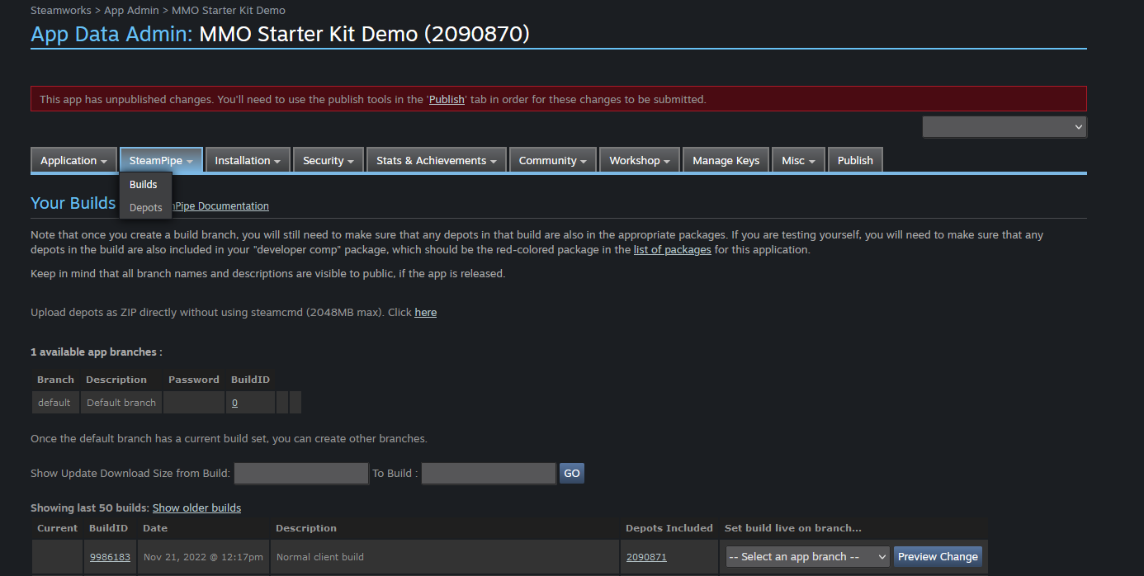

Click “select an app branch” select “default” and click “preview change”, then “set build live now”.

If everything else is ready, you can mark your app build as ready for review.

Note that as a player, in order to get an update to your game in Steam, you need to explicitely shut it down and relaunch it. Steam doesn’t poll for updates very often, but will always poll at startup.

For this reason, I’m planning to add an internal versioning system to avoid older clients connecting to newer server versions.

Optionally:

While in the builds page, you may want to create a new app branch and call it “server”.

Then go through all the steps above and create an uploader for the WindowsServer folder.

You may have noticed the line "setlive" "" “normal-client.vdf”

You can change it to “setlive” “server” and you won’t have to go to the builds page and set the live branch manually.

On your server machine, you may also use [steamcmd.exe to quickly download](https://developer.valvesoftware.com/wiki/SteamCMD#Downloading_an_App) the latest server build when you’re updating both your client & server. More on than later when I get to it myself.

More info from Steam on deployment can be found here: <https://partner.steamgames.com/doc/sdk/uploading>

# Tweaking

There’s a few things that you can tweak immediately to change default behavior.

* Default Camera in BP_PlayerController

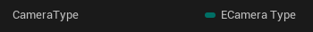

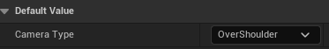

* Persistence Server: .ini file to change between MySQL/SQLite
* Change the default passwords and universal cookie (more on that later)

# Questions

### How to move the mouse cursor with the left stick of the gamepad?

Create an Input Action called IA_GamepadCursor and set its value type to Axis2D

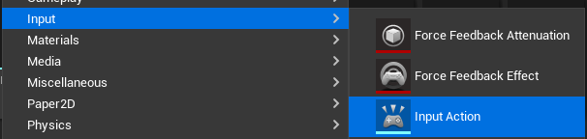



Assuming you work with the over the shoulder camera, open IMC_OverShoulderControls and add a mapping IA_GamepadCursor, give it two control bindings (Gamepad Left Thumbstick Y and X axes), then set up their modifiers:

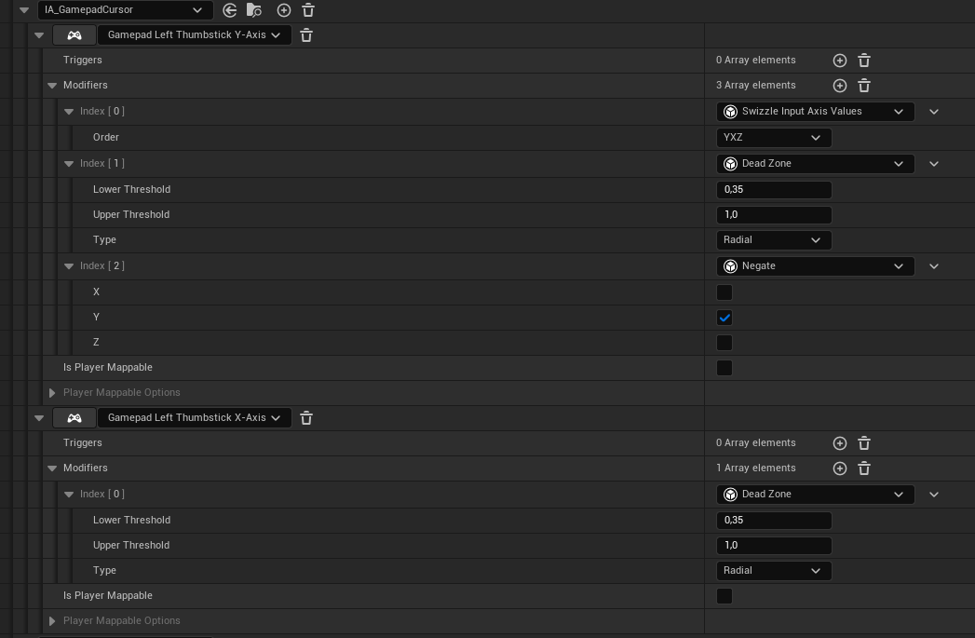

In BP_PlayerController, add the following:

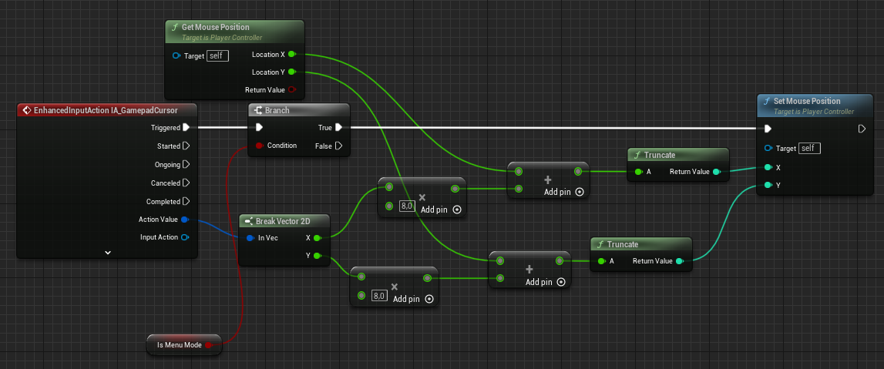

The “8” value is arbitrary, you can tweak it - it controls the cursor speed when it’s moved by the left thumbstick.

You can also tweak the Dead Zone lower threshold - it ignores inputs below a certain value. A lot of gamepads have thumbstick drift, which is noise input when the thumbstick isn’t used, so some minimal value is necessary.

Now all we have to do is prevent the character from running, which is caused by the left thumbstick when in menu mode:

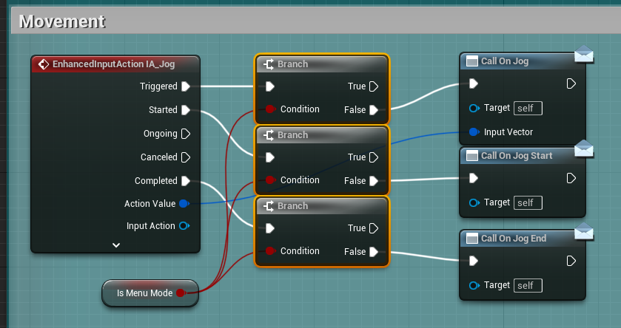

### How to add a new species?

Create an Appearance for the new species as per this section.

Open ECreatureRace enum and add your species:

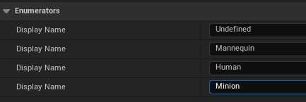

Open **WBP_CharCreation** widget and add a new button for your species:

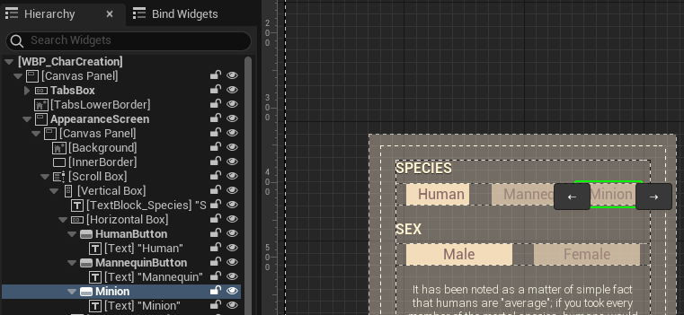

I’ll leave it to you to manage the UI’s logic, but what the button must do after UI changes is the following:

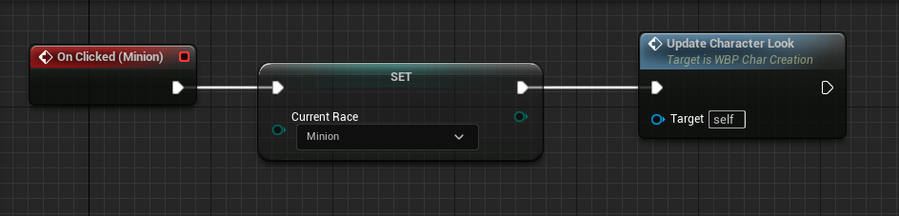

Double “Update Character Look” and add the appearance to the Select node:

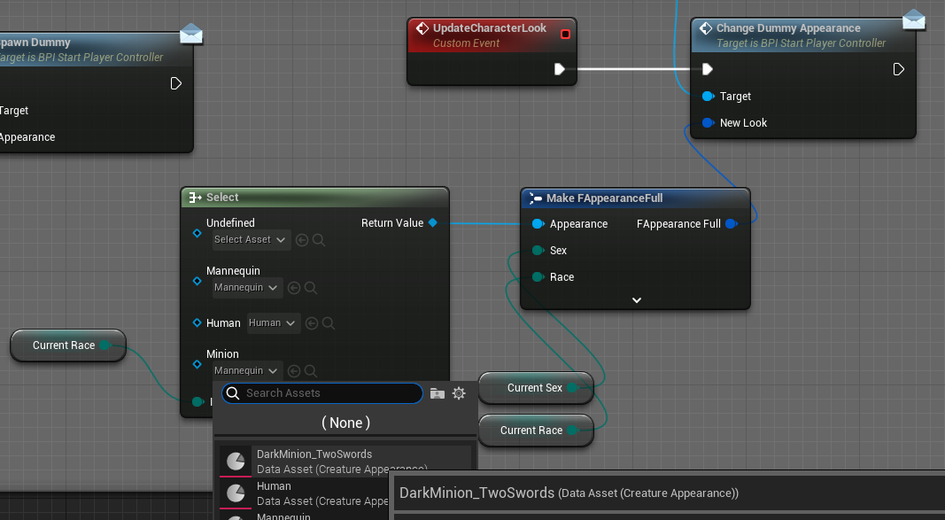

At this point we’ll already have the new race appear on StartMap when creating a character:

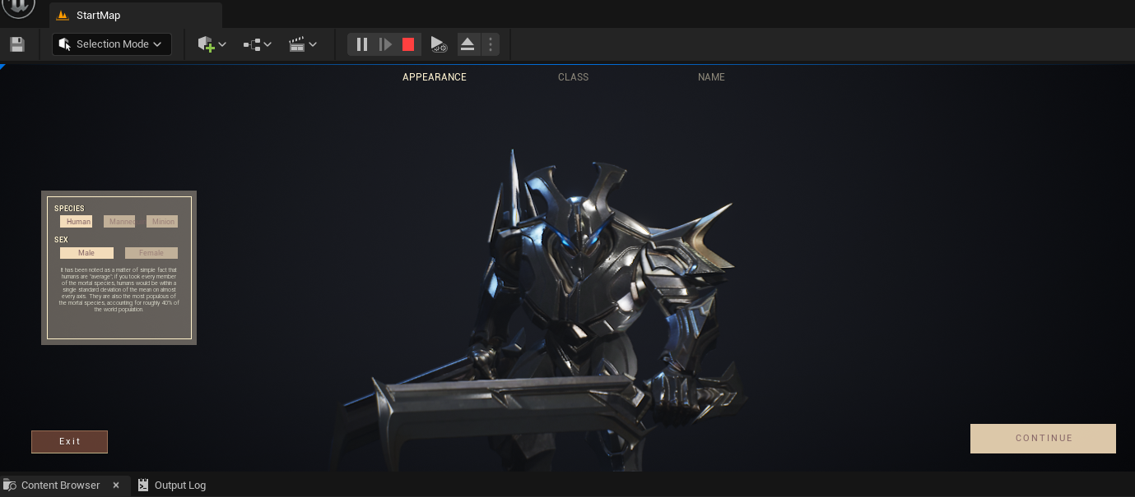

To make it appear in character selection too, go to WBP_CharSelection -> **GetAppearanceAndLevelFromString** and fill a Select here the same way:

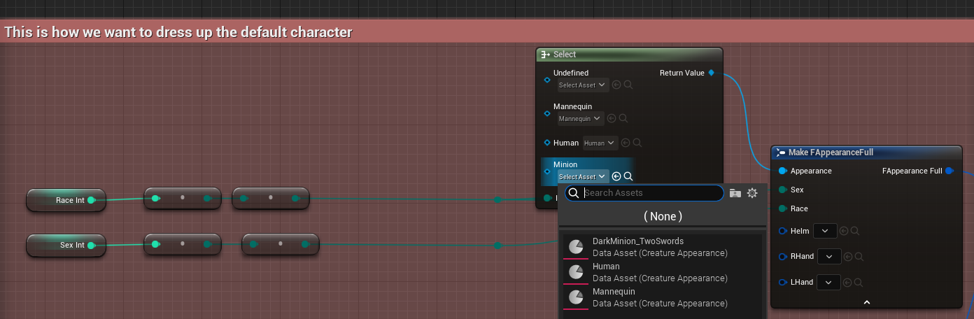

At this point, the character will also look correctly in the Select Character menu:

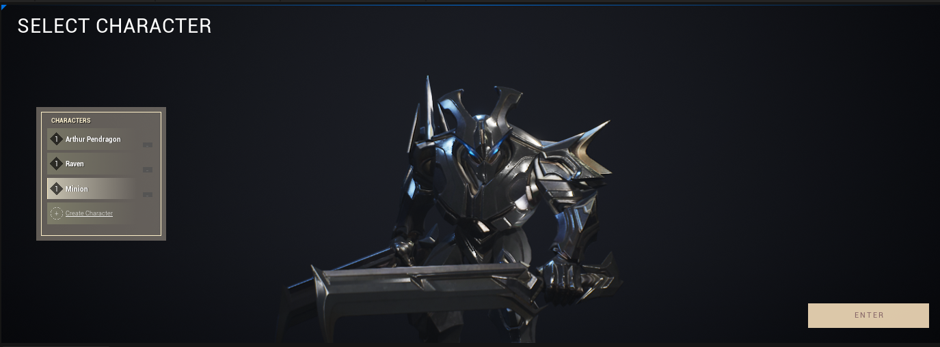

To make the character also appear correctly on LargeMap, open BP_AppearanceComponent and fill in a Select here the same way:

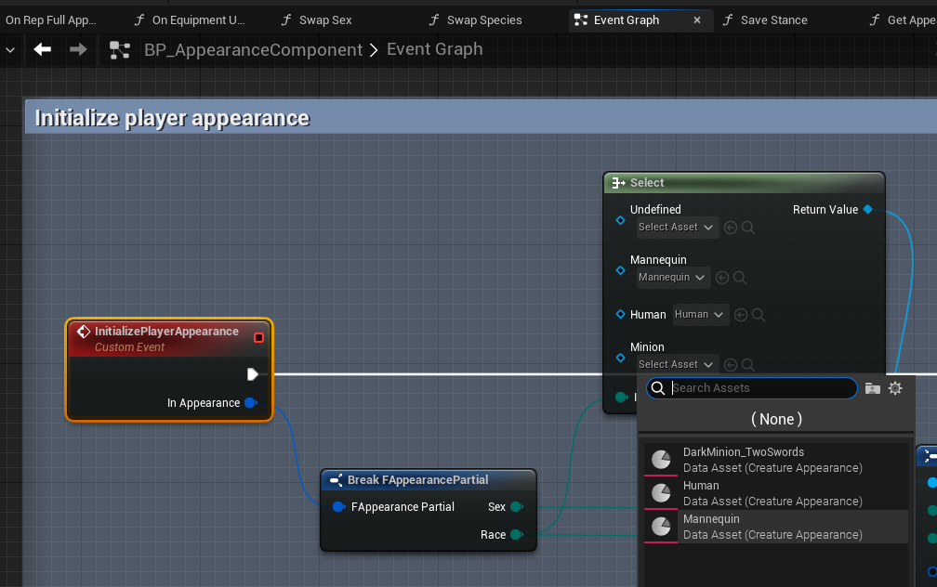

Now that I’ve written it, I realize this should all be set in one Select somewhere. I’ll mark it as a TODO.

Regardless, now the new race is playable:

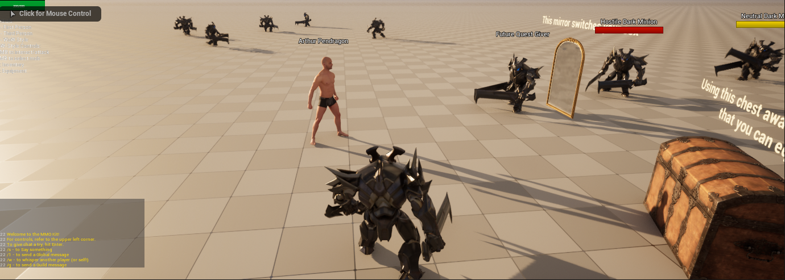

### MySQL error: Unknown collation: 'utf8mb4_0900_as_ci'

Older versions of MySQL don’t have this collation. The solution is to Ctrl+Shift+F in Persistence Server and change all occurrences of **utf8mb4_0900_as_ci** to **utf8mb4_general_ci**

### The head equipment slot / left hand slot doesn’t do anything, why?

Because there’s no logic for this at the moment. Both of them can be implemented in BP_BaseCharacter::SetGear  
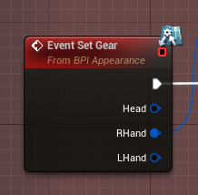

Since the logic for right hand already exists, it should be fairly simple to adapt it to the left hand, provided you create a socket on the skeleton.

For the head, the implementations may vary. Some would prefer to cut the body into parts and “hide” the head mesh, and display the helmet in its stead. Others would attach the helm to the “head” bone and make sure the geometry doesn’t collide. Until an existing system is provided in later updates, it’s up to you to implement the way equipment is to be displayed.

### How to add a new armor slot?

I’ll be using [this asset](https://sketchfab.com/3d-models/shoulder-armor-053d84b1034c429ab476778022d64ff5) as an example, walking you through the entire process:  
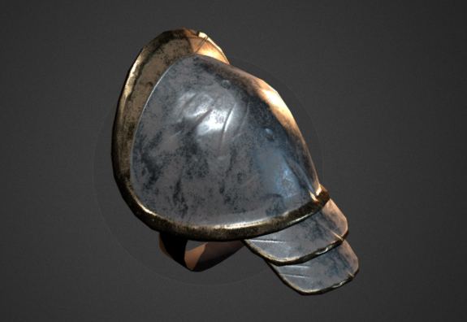

Enable the **GLTF Importer** plugin in Edit->Plugins and restart the editor.

Import it into UE5 with 0.01 uniform scale.

You’ll note that its origin (pivot) is offset by almost 2 m (6 ft) from where we’ll attach it to the shoulder bone:  
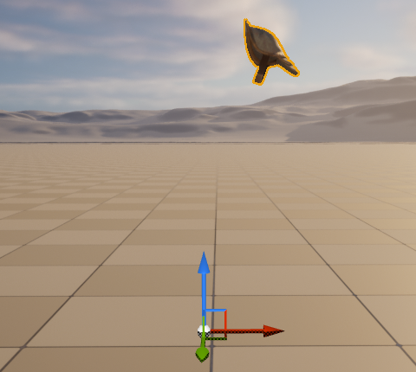

You can either do it in your 3d software of choice, or directly in UE5 using custom plugins (e.g. [Pivot Tool](https://www.unrealengine.com/marketplace/en-US/product/pivot-tool) seems to be popular).  
I’ll export this mesh to Maya, fix it there and reimport it back. To achieve this in Maya, simply hold D + move the pivot. Once you’re happy with it, go to Modify -> Freeze Transformations. The result is:  
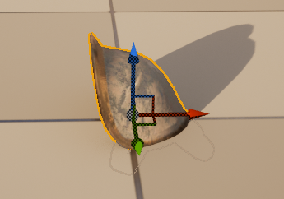

Modify the MMO_Logic/Blueprints/Enums/**EEquipSlot** enum to add a Shoulder slot. Add ids to Description for convenience, starting with 0.  
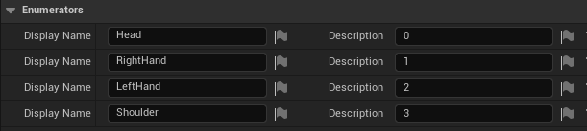

In WBP_Equipment, duplicate the HeadSlot, rename it to ShoulderSlot and move it to a different spot:  
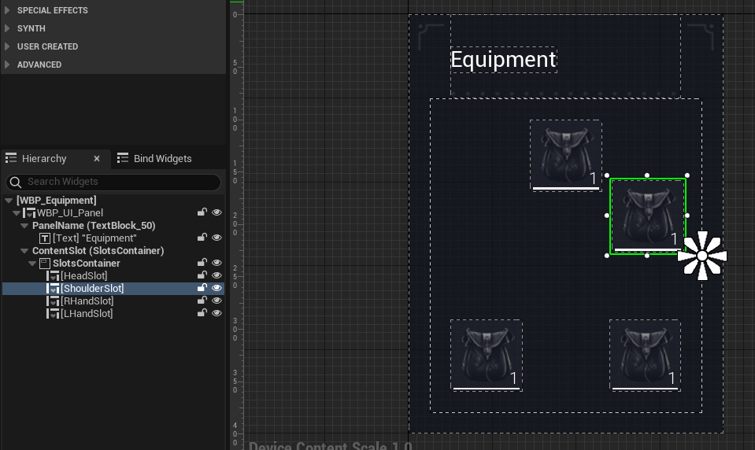

In the right panel, set its SlotId to the same number you had in EEquipSlot, also set its default texture to an icon of your choosing:  
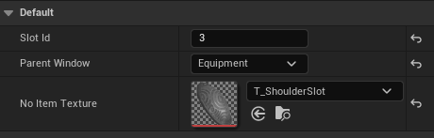

We’re not done yet, but if you launch the game at this point, this is how your equipment window will look like:

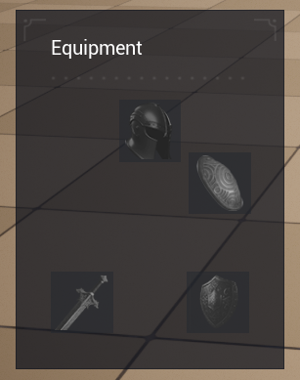

In BP_PlayerController, find the SpawnCharacter function. A few things to change in it. At the right end of the upper chunk, change 3 to 4 Max Slots and add one element to the two arrays:  
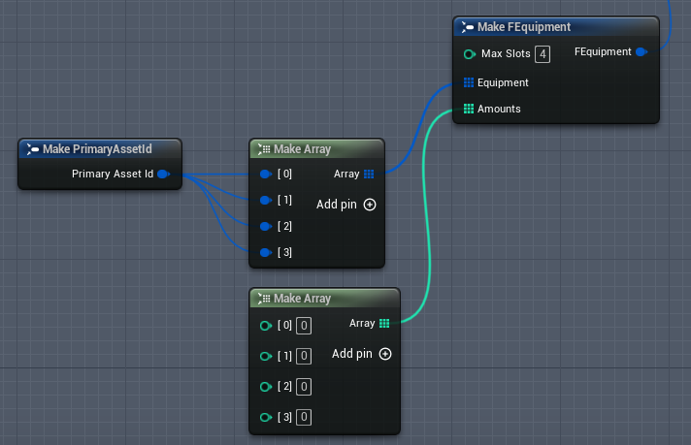

In BP_Equipment_Component, find the Initialize event:  
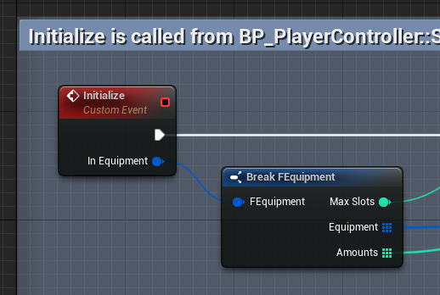

This is the equipment we get from the database. If we’re getting an “old” character with only 3 slots as equipment, we need to “hijack” it to add an empty 4th slot. Create a function called “AddEmptySlots” and set its signature to the following:

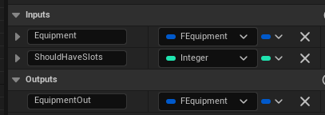

Add two local variables:

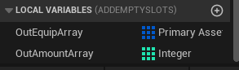

Note that they’re both arrays. The first one is of type “Primary Asset Id”.

The body of the function should be: ([large version](https://i.gyazo.com/a0030959d4902f3416884575b75cc59b.png))  
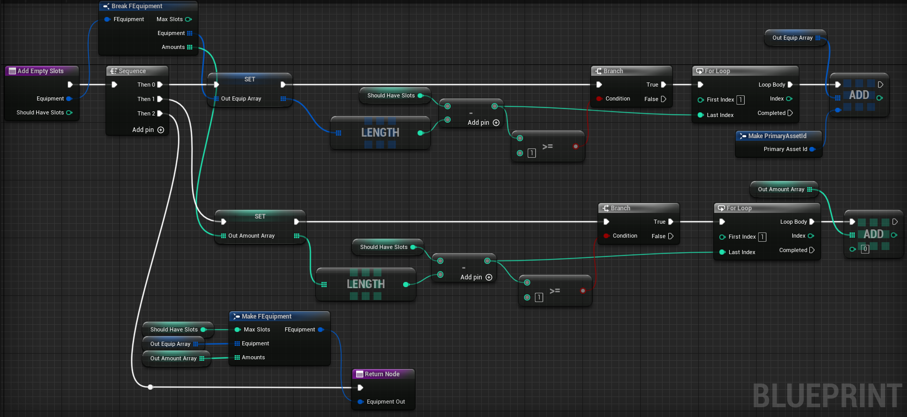

Then go back to the Event Graph and insert this function here. Note that we’re using its “EquipmentOut” result for the Break node.

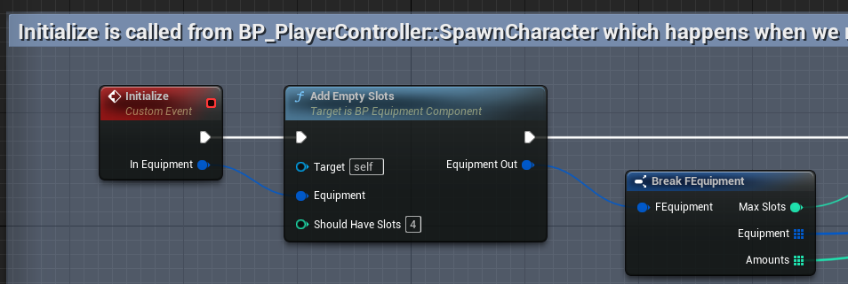

“Should Have Slots” is set to 4, because this is how many slots we’re now going to have. If and when you increase it further, make sure the number is set correctly here.

If you inspect your character in the database, you’ll notice that its equipment is saved like this:

**"Equipment":{"maxSlots":3,"equipment":["","",""],"amounts":[0,0,0]}**

(this is my empty equipment, you may have items in it)

Now launch the game and stop it. After launching it this once and reopening the db, your character will now have 4 equipment slots in the database because of the “AddEmptySlots” code:  
**"Equipment":{"maxSlots":4,"equipment":["","","",""],"amounts":[0,0,0,0]}**

This means everything is going well so far.

Create an item in MMOKit/MMO_Content/Equipment. To remind you how it’s done, Right Click in the Content Browser and select Miscellaneous -> Data Asset, then pick **EquipmentAsset** in the search box.

Set its icon, name, equipslot, etc…  
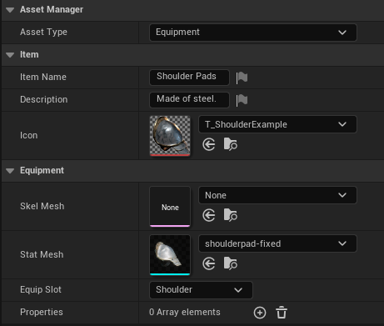

To give yourself an item in the game, simply open BP_SwordGiver and change what item it dispenses:  
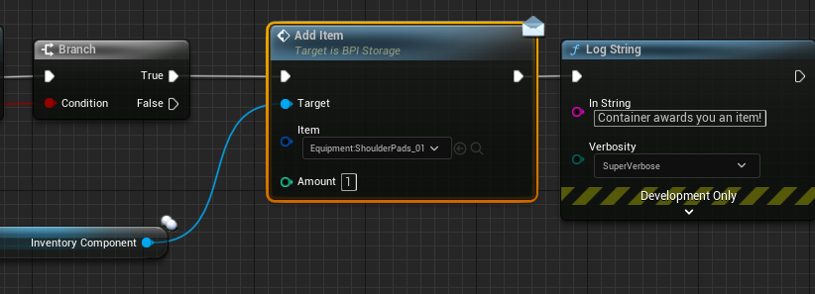

At this point you may be able to give yourself the item in game, but it won’t quite fit into the slot yet.

Go into BP_Equipment_Component -> DoesEquipslotFit function and add the following code for Shoulder:

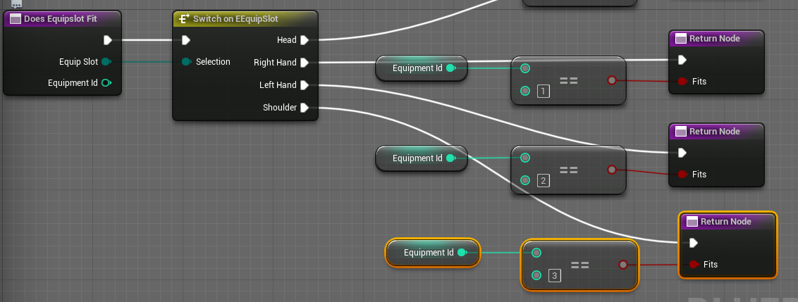

Now your shoulder pad is equippable in the Equipment menu. But it’s not displaying on the character yet.

In BP_Equipment_Component, find OnAppearanceUpdated event dispatcher and add a shoulder input of type Primary Asset Id:  
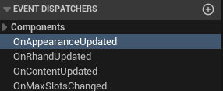 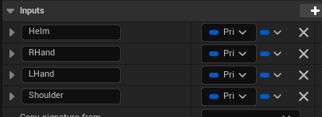

Compile. You may see an error in this node:

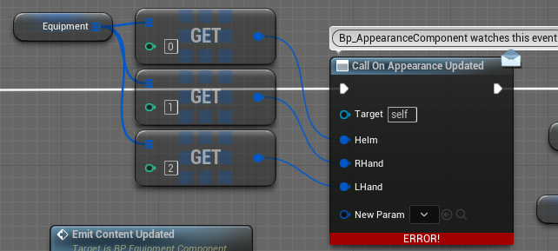

Right Click on it and hit “Refresh Nodes”

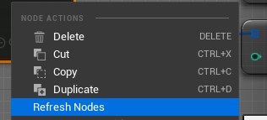

Now feed your shoulder into the pin and compile:

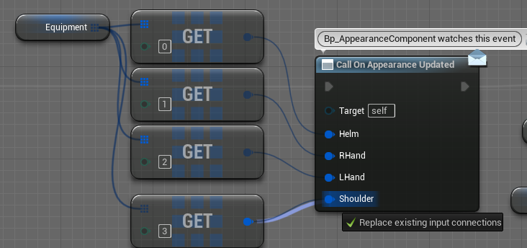

Don’t forget the “3”.

Open BP_AppearanceComponent and find OnEquipmentUpdatesAppearance function. Add an input of the now familiar type and name, compile:  
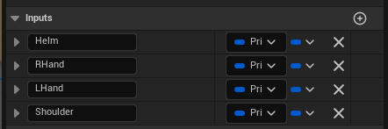

Connect the shoulder to the Make node:

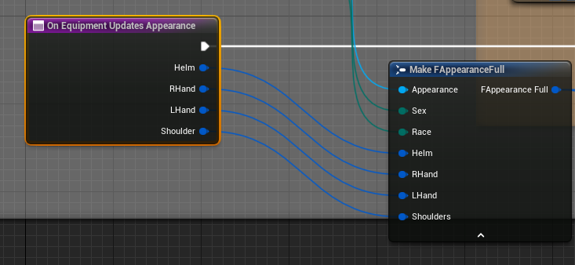

Open MMO_Logic/Blueprints/Struct/**FAppearanceFull** and add a variable of type Primary Asset Id, called Shoulders. Compile.

Open BPI_Appearance, select SetGear function and add an Input of the same type and name. Compile.

Open BP_AppearanceComponent and in the Event Graph, in the UpdateFullAppearance event, connect these two pins:

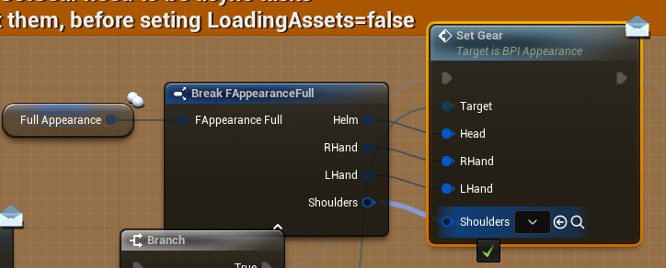

In the same event, add this:  
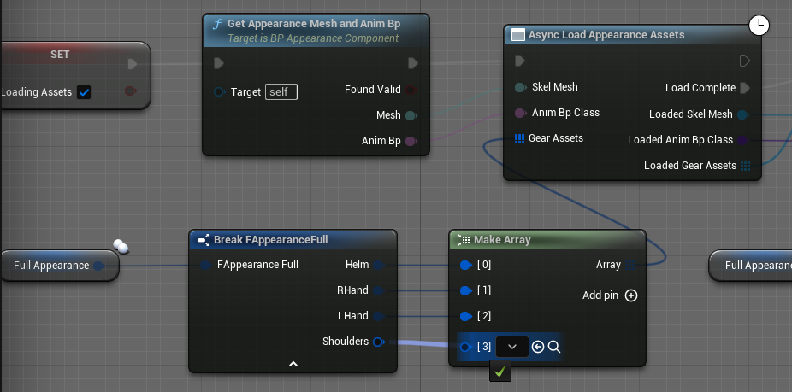

In **SwapSpecies** function, connect shoulders:

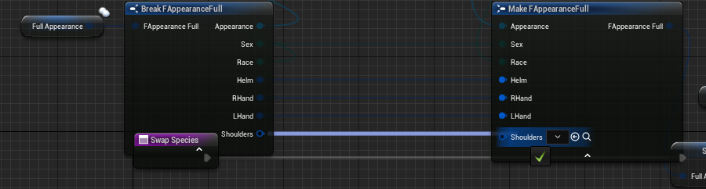

Repeat the same in **SwapSex**.

Open **BP_BaseCharacter**.

Add a variable of type StaticMeshComponent Object Reference, call it ShoulderRight. Then add another one for ShoulderLeft.

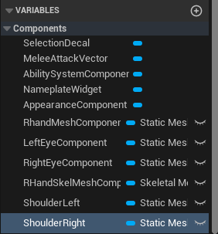

Open the **EmptyGear** function, add this code:

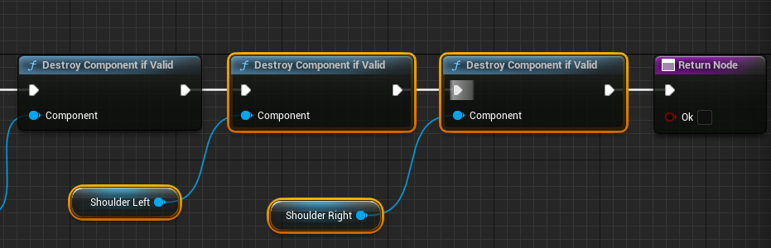

Find the **SetGear** event and add this chunk of code to the second Sequence execution pin:

([full version](https://i.gyazo.com/37291f56ac4bbb5407b7f9bb0ee651ac.jpg), [alt link](https://drive.google.com/file/d/1NwnibORy6klsj6JvSmqdqOHsCg_uwDCX/view?usp=sharing))

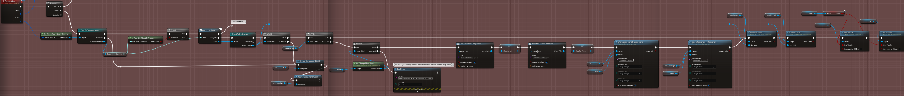

Open **SK_Mannequin_UE4_Male** and in the skeleton tree, attach a socket called **shoulder_rSocket** to the upperarm_r bone. Repeat the same thing with the upperarm_l bone.

Make sure Windows->Details is displaying correctly and adjust their position to mirror each other. Make sure to preview the shoulder pad:  
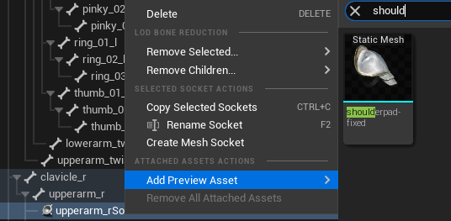

At this point I noticed that my shoulder pad was a bit too big, so I went back into the asset, set its uniform scale to a lower value and reimported it:  
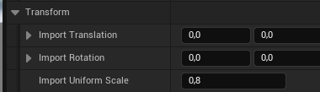 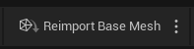

Back to the skeleton, rotate the sockets to get a satisfactory result:  
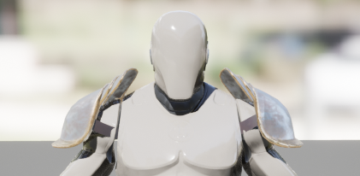

Add the same sockets on the skeletons of SK_man and SK_Woman.

Result:

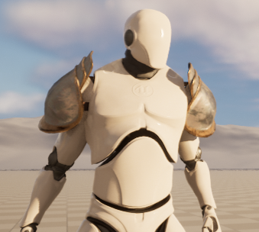 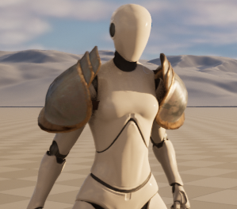

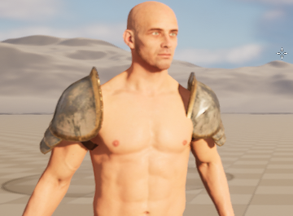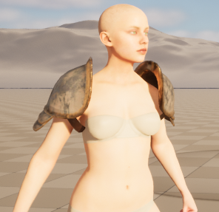

Notice that the pads look a bit big on the female mannequin. To fix this, you can add additional sockets on the mannequin skeleton called shoulder_lSocket_female and shoulder_rSocket_female and switch on sex before picking the socket name in the SetGear event. The _female sockets can have a scale of 0.85 and this would scale the pads down.

However, make sure your other species, i.e. human female skeleton, also has a socket with the same name, then.

There is only one skeleton for the two mannequins, while the humans have two separate skeletons.

So if you do separate sockets for female, the mannequin skeleton will have four shoulder sockets in total, while the human ones will only have sockets of their appropriate sex.

### How to do sprint?

I’m going to assume you’re working with the the Over The Shoulder camera for the purpose of this example.

Create an Input Action in /MMO_Logic/InputConfig and call it **IA_SprintModifier**

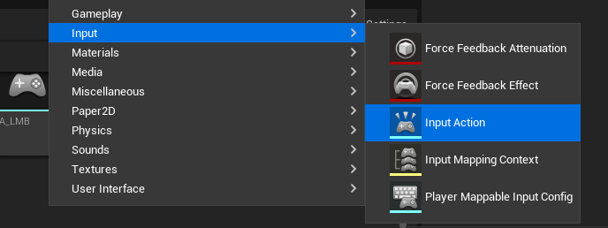

Open **IMC_OverShoulderControls** and add an **IA_SprintModifier** mapping, bound to Left Shift.

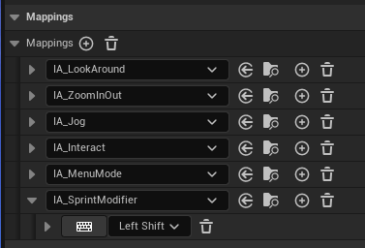

In **BP_PlayerController**, add an **EnhancedInputAction IA_SprintModifier**. In the same class, create an Event Dispatcher called OnSprintModifier with a bool param. Connect the results as follows:

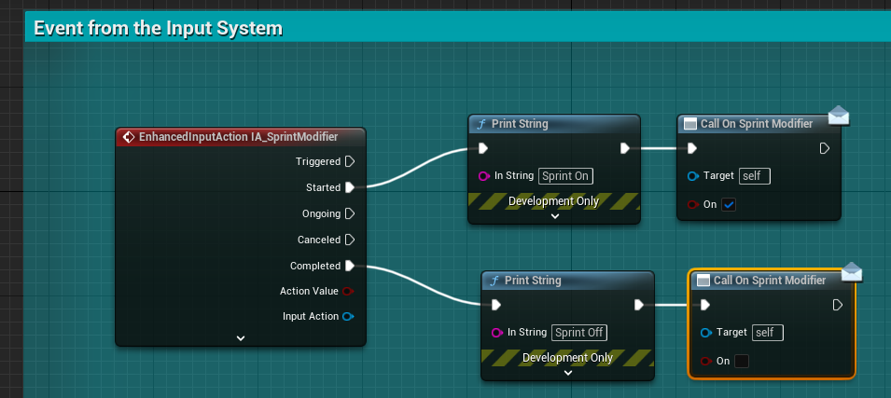

In **BP_BaseCameraComponent**, sign up to the **OnSprintModifier** event (note: it also needs a bool param):

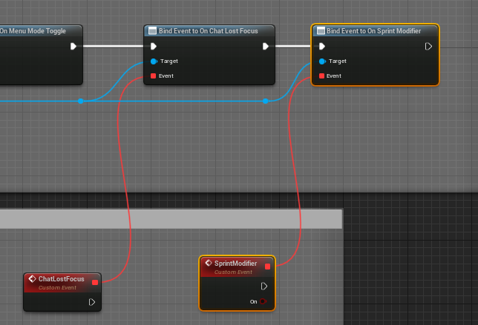

In **BP_BaseCharacter**, add a Reliable Server event:

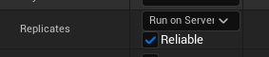

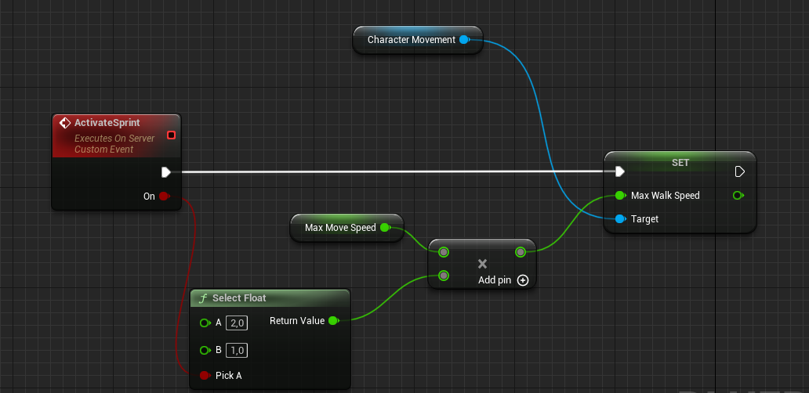

In **BP_OverShoulderComponent**, override SprintModifier function:

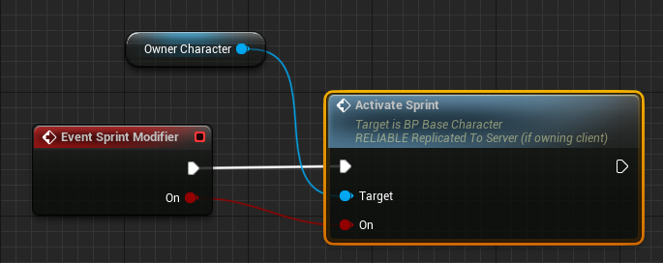

As you can see, it’s a bit of a meandering way of implementing it. If you want a more straightforward approach, you can just call ActivateSprint directly from **BP_PlayerController**.

I had to divide logic into modular FirstPerson/OverTheShoulder/WowStyle components, so that the kit would be flexible and fit all kinds of MMOs. You don’t have to keep using this architecture, it’s up to you.

An important point for the Animation Blueprint is that in this example your actual speed would become 800, but your *MaxMoveSpeed* would remain 400, which would set your *MoveForwardVector* to 2 (see **ABP_ThirdPerson**’s Event Graph). This value would then be passed on to **BS_Movement_ThirdPerson**, which only accepts values from -1 to 1. You can of course change it and add sprint animations to values 2 and the negative value of your choosing. This would let you see different animations while a character is sprinting.

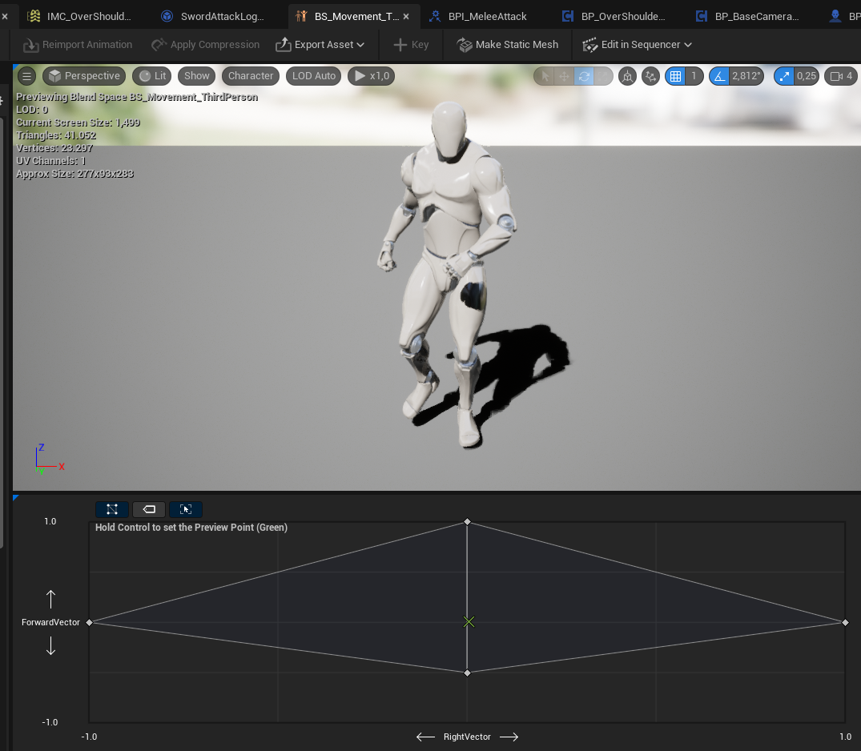

### How to do level ups?

I recorded a 14 min video for to answer this question on Discord. My microphone is quiet, so turn up the volume. I also haven’t worked with data tables for a while, so I spent a few minutes just trying to remember stuff.

[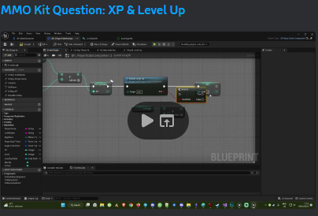](https://www.youtube.com/watch?v=mH-ScKpnEzk)